Finsley House

Parents Handbook
(Easy read)



In this handbook you’ll learn…

- Who are the Managers & Social worker
- What is Finsley house
- Three stages of assessment
- Assessment tools
- CCTV at Finsley
- What Do I need to bring?
- Am I allowed visitors?
- Your flat
- Staff at Finsley House
- What will I learn at Finsley?
- Time in the centre
- Events at Finsley House
- Rules at Finsley House
- Fire evacuation
- How can I make a complaint?
- Useful Contact Details
- Local Amenities

Manager and social workers

Rebecca Burridge – Interim Manager
Hello! I am the Interim Manager here at Finsley House. If you have any concerns, issues, or questions during your stay, please don’t hesitate to reach out to me. Whether you need assistance with something specific, have feedback to share, or just need someone to talk to about any challenges, I am here to support you. My goal is to ensure that your stay is as comfortable and positive as possible, so please feel free to approach me at any time. I will do my utmost to assist you and address your concerns to the best of my ability. Remember, no issue is too small, and your well-being is my priority.
Chantelle Canavan – Deputy Manager
If you have any concerns in your flat then come and let me know and I will get it sorted for you. I can help with any general questions you will have about anything at Finsley House.



Social Workers

There will be a team of worker completing your assessment whilst at Finsley House. They will be around during the days in the week. They will also work with you and you will have discussions about your past and your future in social work sessions. They will be open and honest with you about everything and will ease any worries you have. 😊
Imogen Dewhurst – Social Worker
Imogen is our assessing social worker at Finsley House. Imogen will support throughout your assessment, completing assessment sessions with you and write up your reports.



What is Finsley house?

Finsley House is a place for parents to bond with their child/children for 13 weeks. You will have your own flat where you’ll stay, you will have your own en-suite bathroom for you and your family, and your own kitchen area and lounge area. Also you have a communal room which is situated by the staff office which is for meetings, events and group sessions.
Staff are here 24 hours a day to support you in all ways such as offering you advice and even teaching you lots of things you may not know already.

Whilst you are at Finsley House you will be assessed on how you care for your child and how we can support you and how other professionals can support you become the best parents you can be. Although it can be scary coming here, everyone wants to help and support you.

This is your opportunity to show everyone that you can keep your child safe and give them everything they need.



The Three Stages of Assessment
- Full observation

At this point of the assessment staff will attend your flat when you carry out any care tasks. These consist of; bottle preparation, bottle feed, nappy change, sterilising bottles, and bathing. Furthermore, any outings with your child to places such as the supermarket, baby groups etc. This stage will indicate to us whether you can safely and competently carry out care of your baby without staff prompting or intervention.

- Partial stand back

Following on from Full observations, is the Partial Standback stage of your assessment, if the above-mentioned criteria has been met, ie you can prepare a bottle, change a nappy, feed your baby without prompting, in a safe and consistent manner then you will no longer require staff to attend your flat to observe this. This would need to be confirmed by our onsite social worker, your social worker and the management team. However, you will still continue to go to places such as the supermarket, baby groups, appointments with a staff member.

- Full stand back
Following on from the above, if you consistently meet all your baby’s basic care needs, you regularly take your baby to baby groups, the final stage is that of full stand back, whereby you may go to baby groups/Sure Start centres, appointments etc without staff present. This will be at a later stage of the assessment and will be agreed by social workers and the management team.




Assessment Tools
Freedom Programme
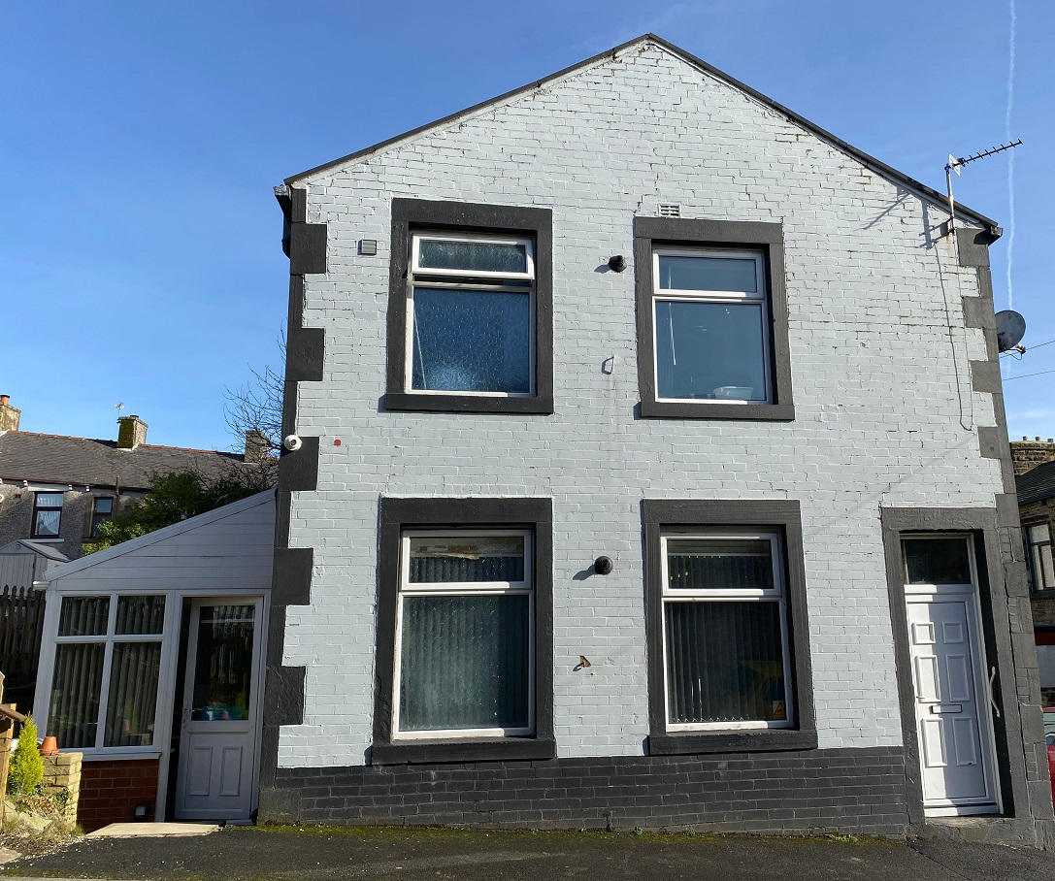
The Freedom Programme is a domestic violence programme which was created by and is run by Pat Craven and evolved from her work with perpetrators of domestic violence. The Programme was primarily designed for women as victims of domestic violence, since research shows that in the vast majority of cases of serious abuse are male on female. This will be requested by your local authority social worker if required.

ParentAssess
Parent Assess is an assessment process that aims to fit the needs of all adults. The assessment works in a traffic light system to help identify what the parent is doing well, what needs work and what is an immediate risk. The assessment allows the social worker to focus on areas of concern to help support and improve their parenting. The assessment has a court version and an easy read parent version so it is accessible for all. The assessment focusses on domestic abuse, mental health, basic care and parental capacity.
The assessment style is used to:
- Understand the parent’s difficulties ​
- Enable the parent to understand ​
- Not setting the bar higher ​
- The child must be central to the analysis of parenting​
- The parent’s ability to change and adapt must be assessed​
- The support network must be assessed​
- Explain the outcome in a way the parent can understand ​
- A simple traffic light system is used to relay views and outcomes


How you feel
Whilst at Finsley house you will have resident meeting were you and other families can give your views wishes and feelings. Alternative to this, we will also ask you for individual feedback where you can highlight any concerns or just mention anything you wish to discuss.
Every week you will have a weekly appraisal where staff will go through the previous week events. They will look at basic care, child development and engagement in the centre. We will highlight any areas of improvements and areas that you are doing well. This will also be another opportunity to express your views wishes and feelings.
At any point if your feel like you are not being listened to, you can ask staff at any time for a complaints form. In your flat is an easy read guide to making a complaint and attached to this form is another copy of a complaints form. Alternatively you may wish to speak to our psychotherapist who holds a weekly talking/listening service for all families which is done virtually and offers support and guidance relating to any issues you may have.
What is an advocate
An advocate is an independent expert who can help support you in navigating the social care system. As well as providing practical advice, they can work on your behalf to ensure all the rules are being followed correctly, and you’re getting everything you’re entitled to.
If you do wish to have an advocate then you can speak to your social worker who can put a request in for you. Alternatively a member of staff at Finsley house can support you with this. You can also make a self-request for an advocate if you wish.
“Staff have been really nice, enjoyed the hands on work, very supportive and honest from the start, direct work has taught us a lot and helped us to come away with lots of certificates” – Feedback from previous residents.
“From a face to face working relationship the team are effective and professional, this unit is a nurturing, friendly environment for parents to learn” – Professional feedback from SW


If you require an interpreter at any time within your stay at Finsley House or prior to commencement of your placement, please make your social worker aware of this. Or alternatively call Language Line on: 0800 169 2879

CCTV in Finsley
The centre operates 24-hour CCTV surveillance, all staff are trained in safeguarding children and how to respond in line with our local Safeguarding Children’s Board.
The cameras are situated in communal areas such as:
front and back entrances
hallways and stairways
living room
kitchen
bedroom (only over baby’s cot)
Your baby is required to remain on CCTV at all times unless there is a staff member physically present until you have progressed and evidenced throughout your assessment that you are able to parent your child safely and keep them free from harm.
We offer the following levels of CCTV monitoring within the centre:
Full CCTV monitoring. Intermittent CCTV monitoring of 30 minutes/60-minute intervals.
Random CCTV monitoring.
The level of CCTV monitoring will be agreed before the placement will start and will be discussed in a pre-placement meeting. Here you will be able to ask any questions you might have about CCTV. The level of CCTV monitoring can change during your placement but this will be discussed with you and your child’s social worker before any changes take place.
We know it can be a scary thought being on CCTV so we want to make sure you feel as comfortable as possible. We may ask you each week during your appraisals how you are feeling about the CCTV.
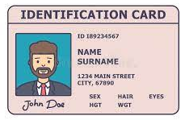

What do I need to bring?

It’s nice to make your Room feel like home so we advise you to bring things like photo frames, laptops and all your favourite things.

Most importantly we do advise you to bring all essential things for your baby such as formula, sterilisers, wipes, cotton wool, nappies, clothes for your baby and yourself. We strongly advise that you bring your own pram, rain cover and car seat.

Feel free to bring things like deodorants, soap, shower gels, hair products etc. You may keep your phone however we do not give permission for you to record staff or the building.

Your flat will have things such as cutlery, kettle, microwave, fridge furniture etc so all your personal things are what we recommend.
Don’t forget to bring your identification with you to register at the GP or set up a bank account!

It is also your role to complete a weekly shopping list as you are responsible for making sure that you have enough food and essentials to last week by week. This along side the gas and electric are what you will be financially responsible for.



Am I allowed Visitors?
Within Finsley House families are permitted to have visitors but all visitors must be approved by the placing Local Authority, all visits must be pre-arranged with the staffing team at Finsley House, we ask families to give us 48 hours’ notice of any visit that may take place. You can have visitors come to see you as long as this is okay with your child’s social worker. Usually, visitors can stay from 2-3 hours, once or twice a week but this can be arranged to your needs. All visitors must abide by the same rules as you as mentioned in the ‘house rules’ section, we will not tolerate abuse to staff or about staff or other residents, this may result in visitations being revoked.

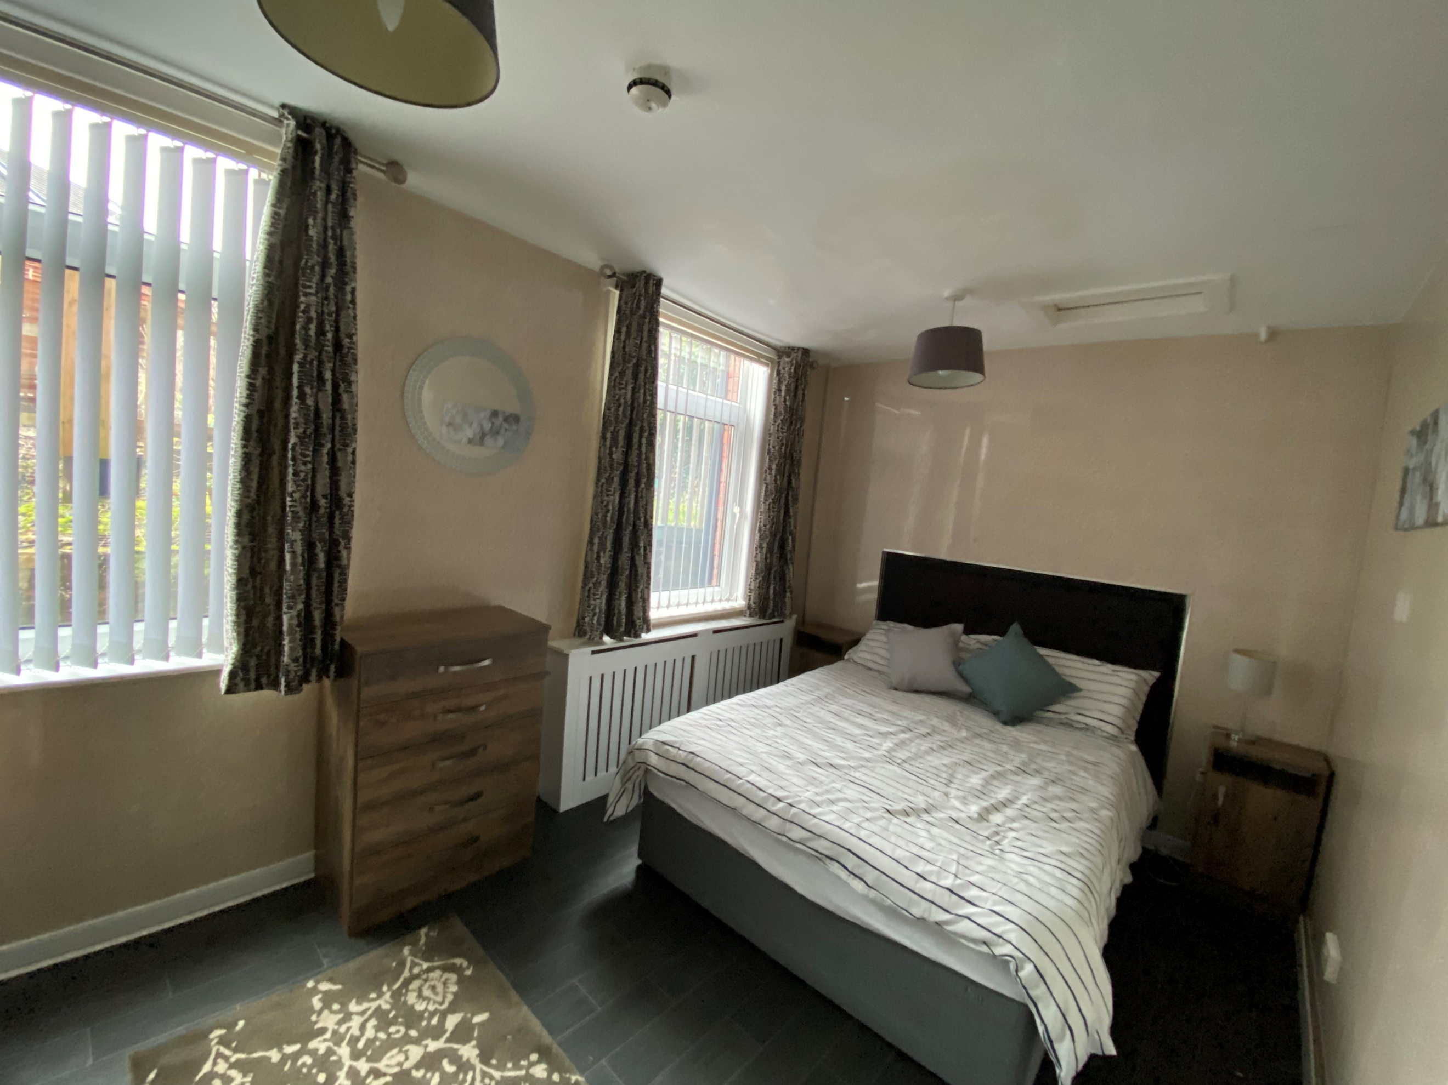
Your Flat
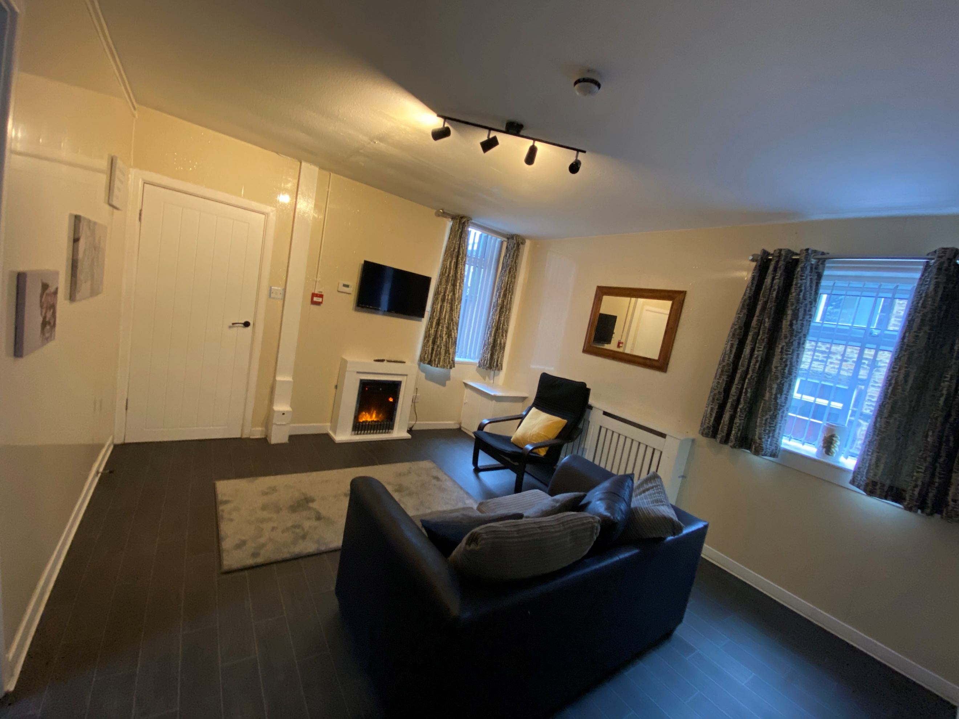

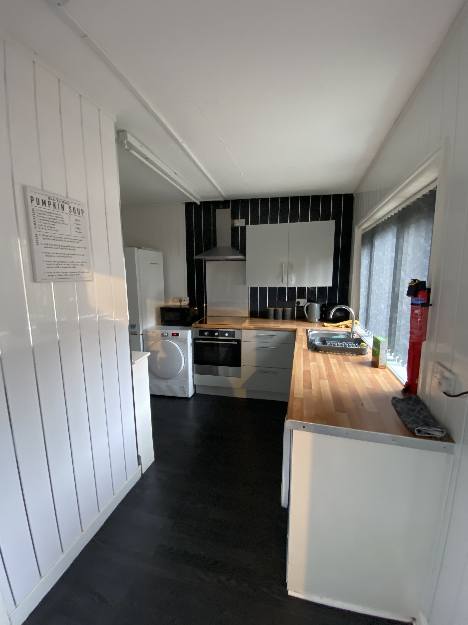

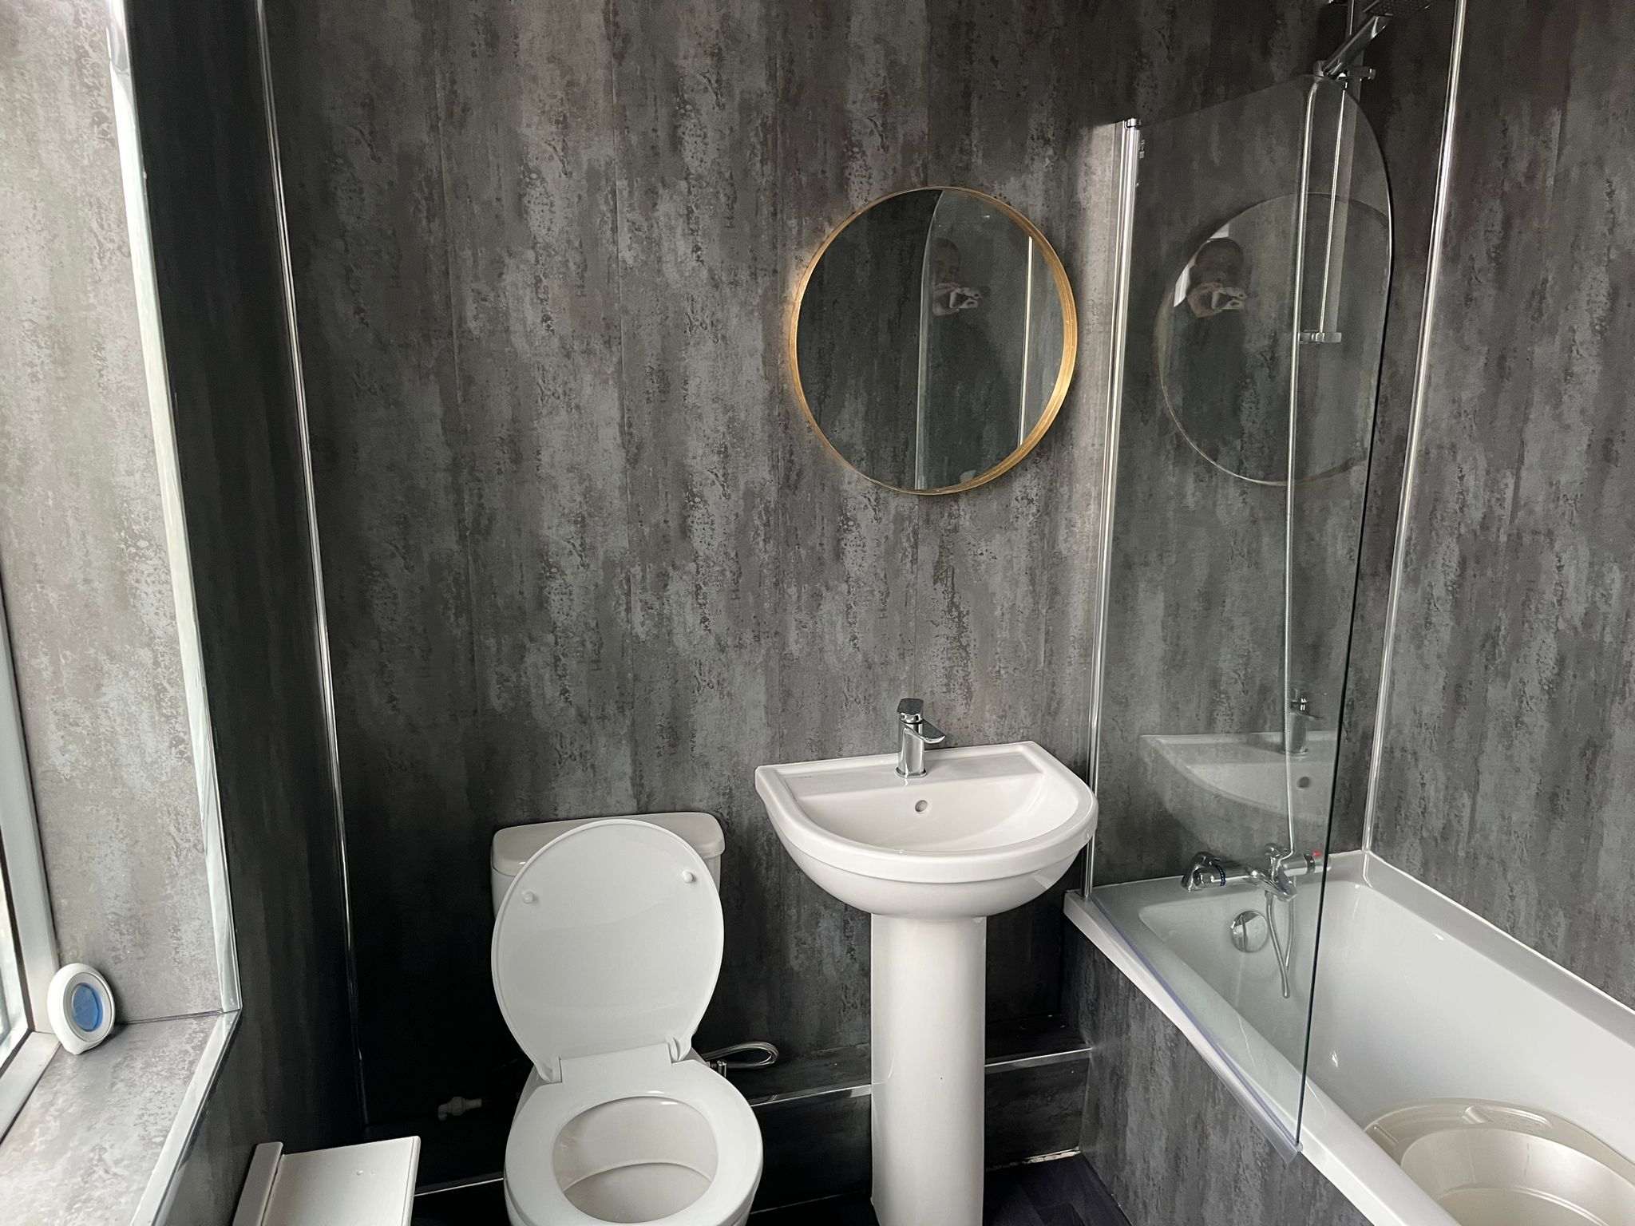

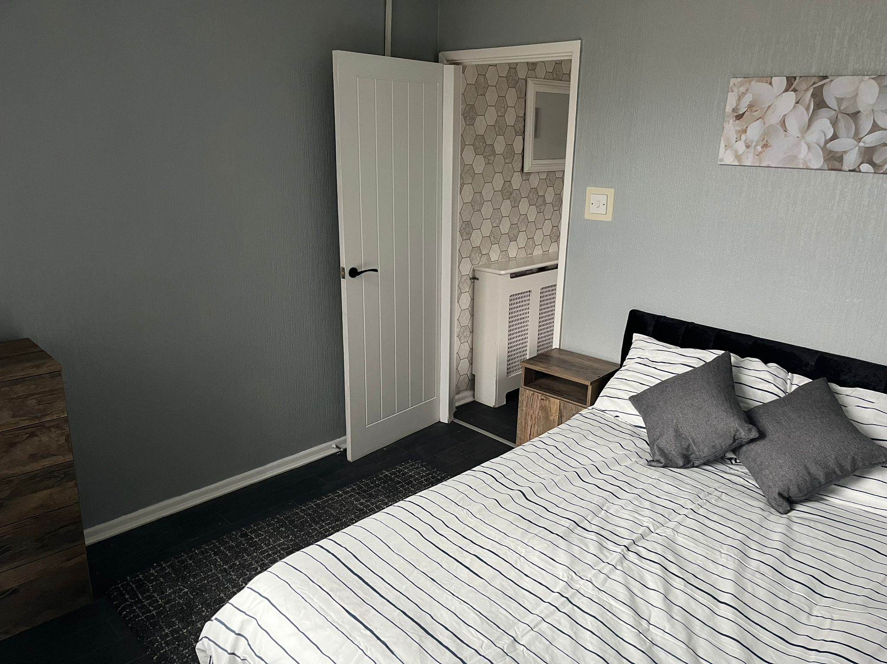

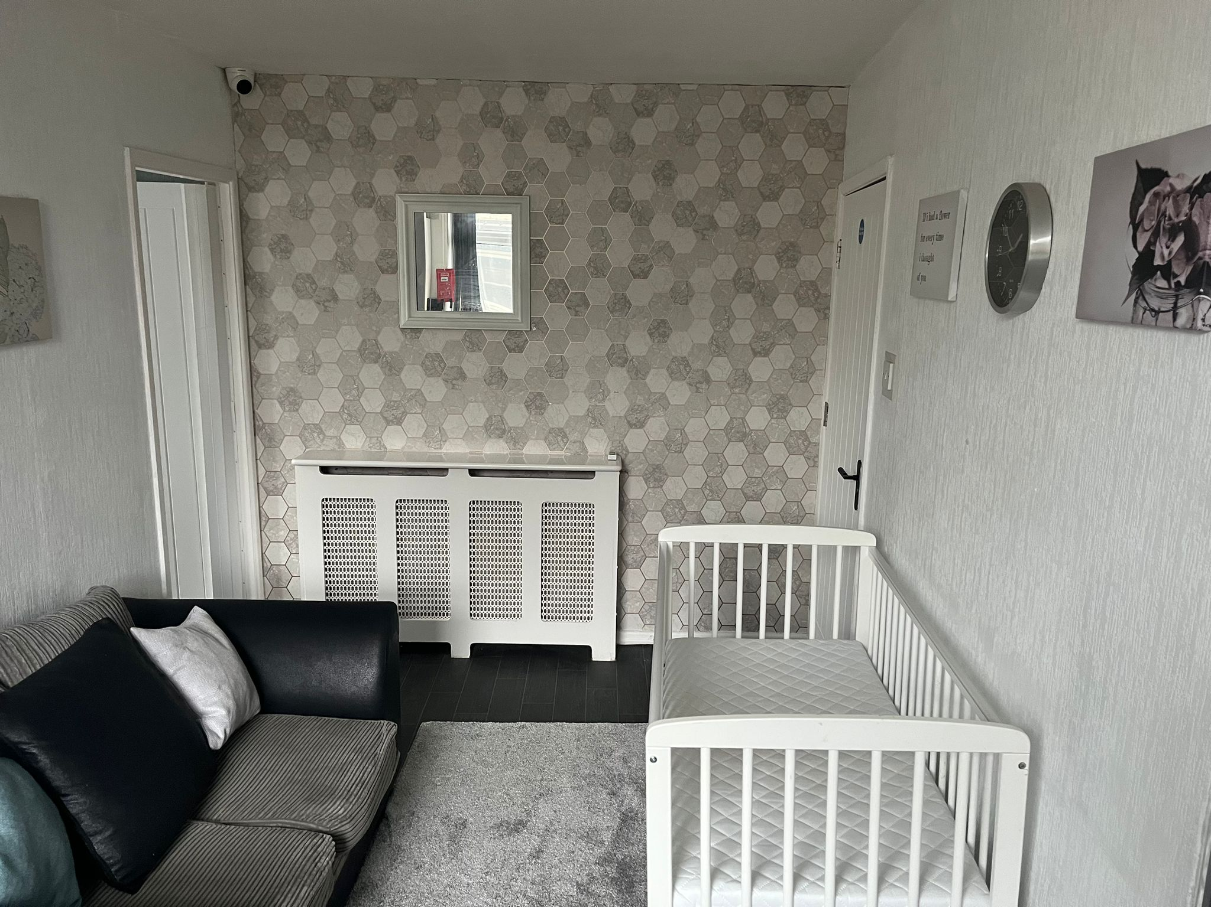
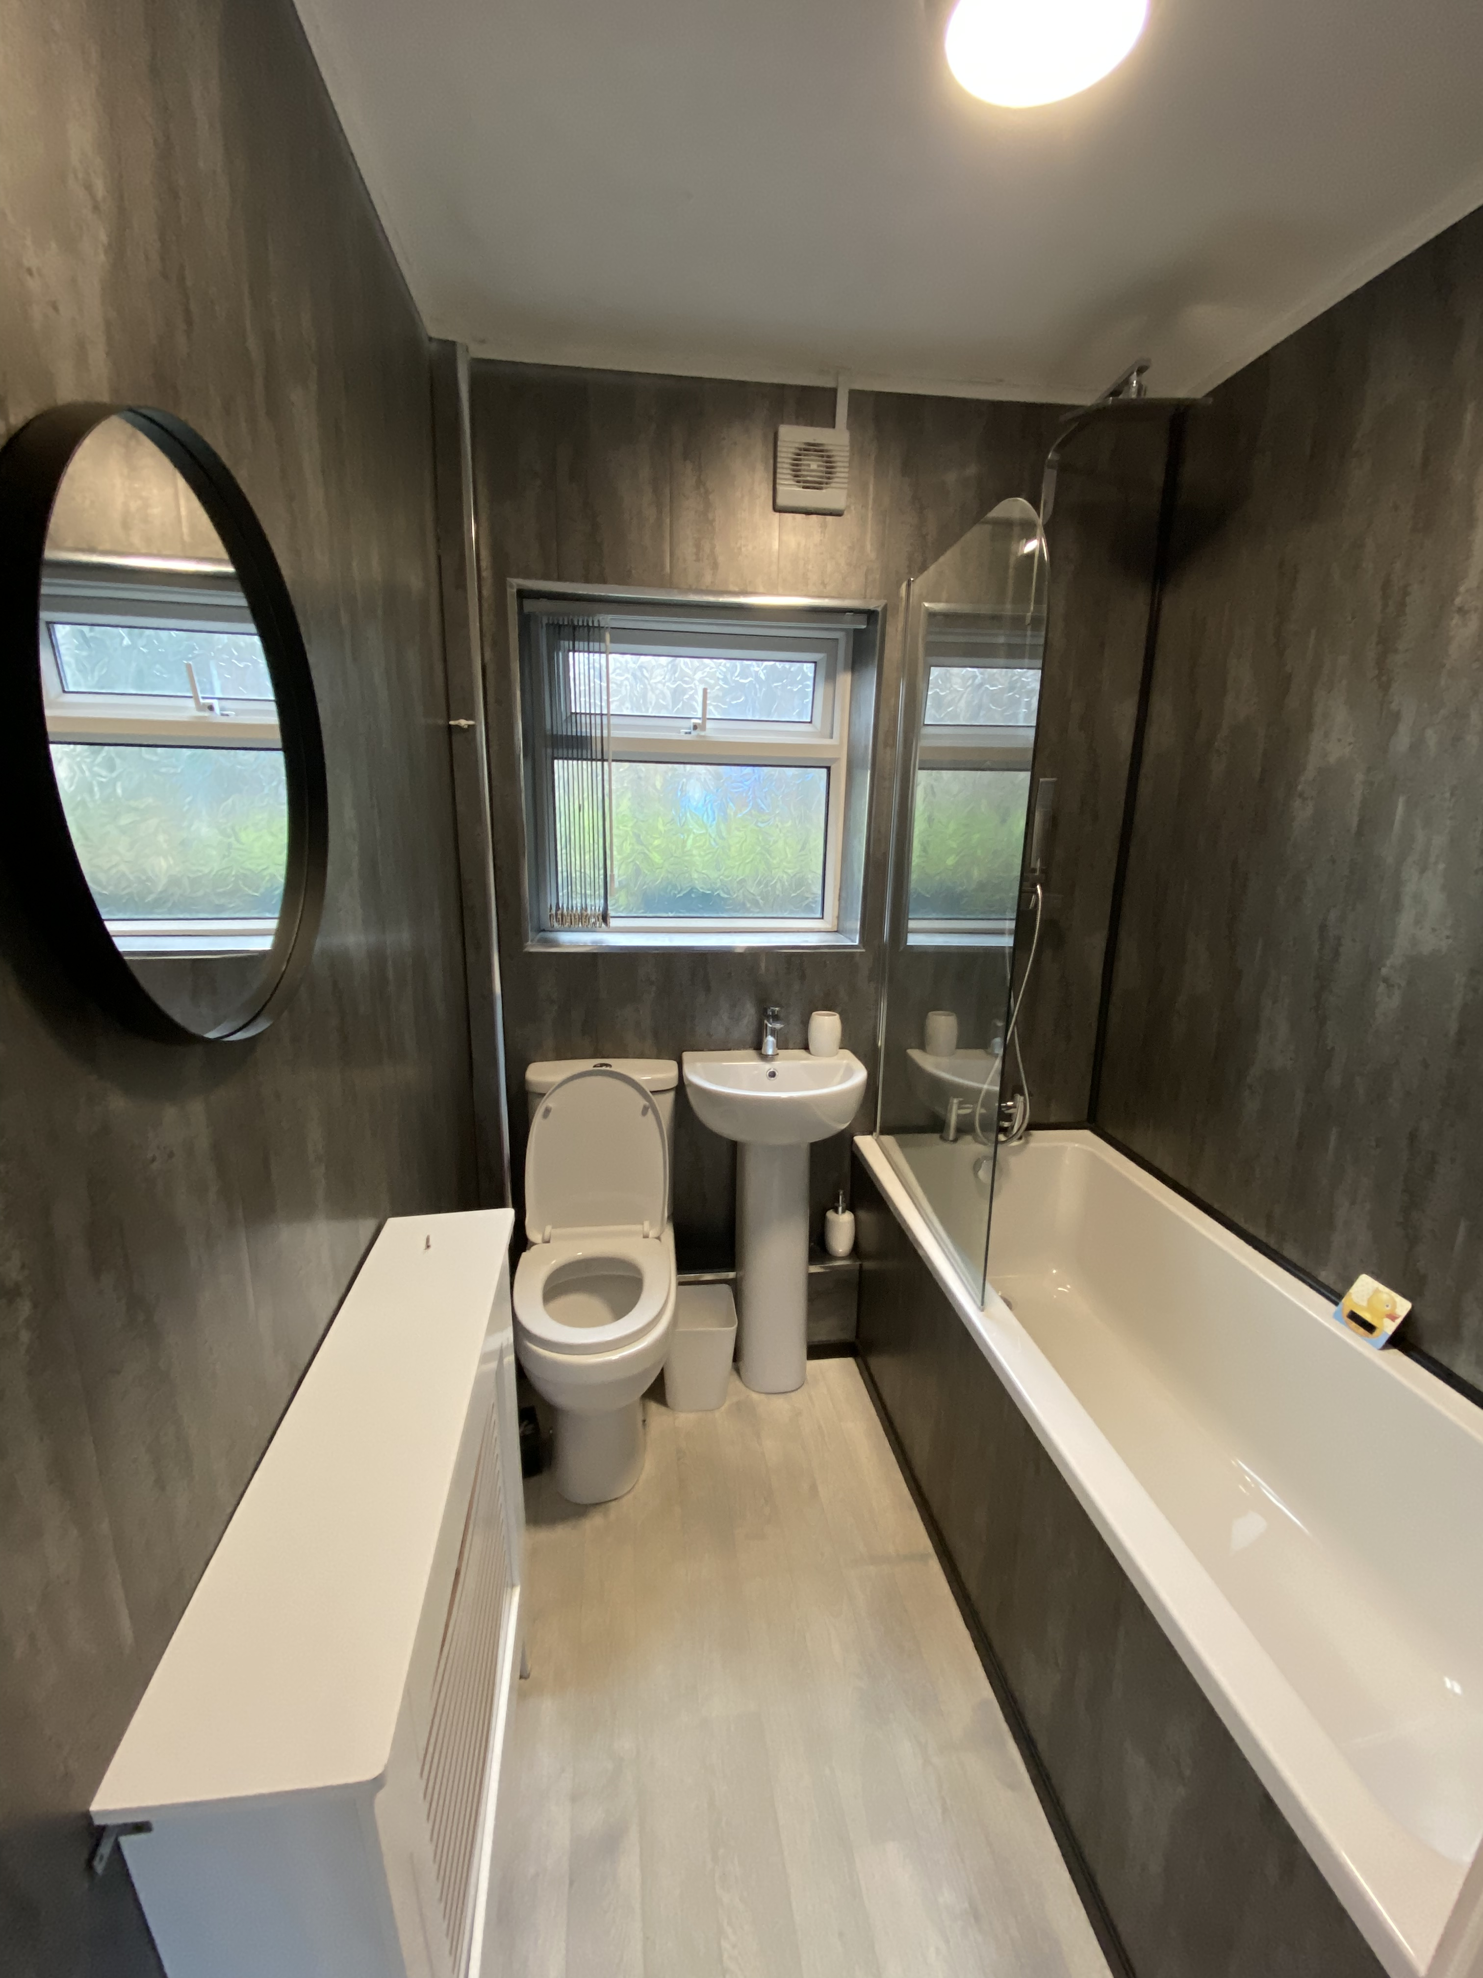

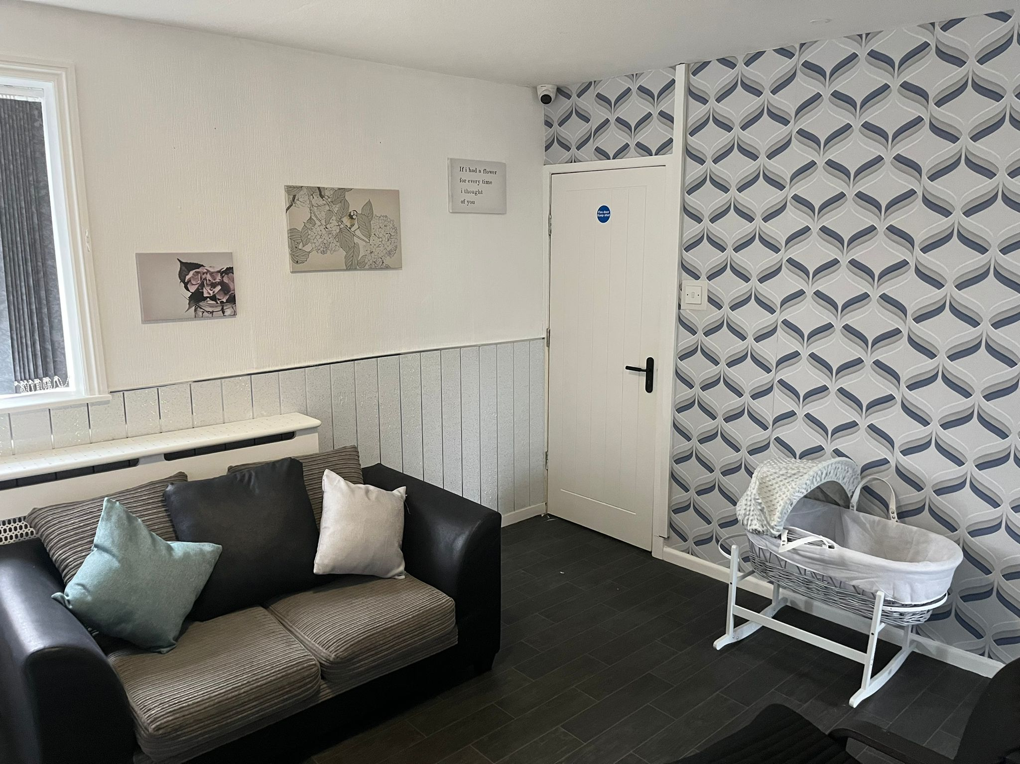

Staff at Finsley House
There are friendly people who work here at Finsley House, they are known as Family Support Workers. They will visit your flat and spend time with you and your family and observe with tasks such as preparing a bottle for your baby, feeding your baby, changing your baby’s nappy and giving your baby a bath. Below you can meet the team who are all trained in Paediatric First aid.
Zoe Mitchell
Fathima Khatun
Ceara Holmes
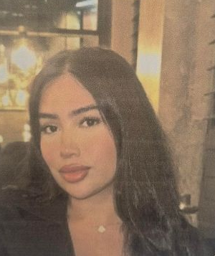

Ceara has care experience and shows good leadership skills and is currently at university studying counselling.

Fathima has worked for Kaleidoscope since 2024. Fathima has a BA hons in childhood studies. Fathima has experience in SEN.
Zoe has worked here for 6 months and has a lot of experience working with children and families. Specialises in Nursery Practitioner and children residential mental health.
Joy Ojugbeli
Ariba Abid
Karen Ingham
Joy Ojugbeli


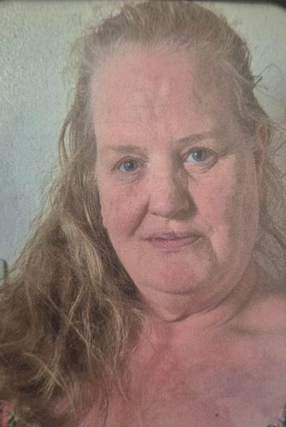

What are observations?
Ariba has been with us since November 2023 and has a childcare qualification & has previously worked in nurseries and schools.
Karen has been with us since September 2023 and has previously worked with recovery and support.
Joy has been with us since 2024 and has previously worked in a children’s residential home and brought her skills and adapted these to work with us.



When you arrive you will use the buzzer in the flat to get staffs attention so they can come to you when completing basic care. It is important we observe these so we can support you with anything you need. At first this may be over whelming but we just want to make sure your child is safe and you have all the support you may need.
Washing/Sterilising bottles, preparing a feed, Offering a meal, Offering a bottle, Nappy change, Bathing & top and tailing, Giving medication and Body check
Staff will always knock on the door before they enter your flat. When you need them, ring the bell. This could be for many reasons not just for task observations, we can support you in many ways.
What you learn about at Finsley House
Apart from learning about your baby, you will also learn about the different illnesses, development and all aspects of babies. Staff also support you to cook food for yourself and your child and offer meal plans, routines and action plans. This is known as Direct Work. When you arrive at Finsley house you will be given a plan of what direct work will be completed and on what date they will be done. This will allow you to plan your week. Once you have had your initial assessment another plan will be formulated for the work to be completed in the final weeks of your assessment and you will be given a copy of this.
You can also attend various courses at Finsley House or elsewhere, these are to help you gain more knowledge and even qualifications.
Each member of staff has his/her own area of knowledge and will use this to equip you for when you leave Finsley House, for example budgeting and how to utilise your finances, creating CV’s so that you can find work, you will also complete some online training (on minded.org) that may help you gain employment or increase your knowledge for when you return home.



Time in the centre

When undertaking a parenting assessment within Finsley House parents are expected to spend at least 6 hours in the centre per day to ensure that all sessions with the Social Worker are completed, and all other assessment work is on time for the family and the local authority.
At times this can seem like a lot and can be very overwhelming however, this is a brief period of time to work with us. You may feel like it is getting too difficult, come and speak to staff we can explain anything and re-assure you. Staff at Finsley will be open with you about everything. You will be kept up to date with everything, we won’t hide anything and will work open and honestly with you. We also expect the same from you we expect you to work openly and honestly with us.
Events at Finsley House

While at Finsley House you’ll have the opportunity to participate in our festive events and our weekly sensory sessions, activity evenings and weekly meal days on a Sunday day. You will also have the chance to attend our monthly social outing events.




Rules at Finsley House
- Ask staff for help and advice if you need it
- Sign in your medication as soon as you get it
- Ensure that babies sleep in their own cots or Moses baskets, staff will show the correct position for baby’s to go to sleep
- Adjust your radiator thermostats in your room so that it is not too hot or too cold. If for any reason the temperature is not right please inform staff immediately.
- Look after all your possessions as if they are lost or stolen Finsley House will not be held responsible.
- Do not lend or borrow any items to other residents, also do not lend or borrow any money to/from anyone.
- Please ensure you know what things are yours when coming to Finsley House. We will complete a checklist with you to avoid any misunderstandings at a later date.
- Always make sure that you keep your flat clean and tidy. Staff will support you with hygiene of the flat, if required photos can be taken of the flat as evidence.
- Don’t bring alcohol into Finsley House (this will cause your assessment to be terminated)
- Don’t bring drugs into Finsley House (this will cause your assessment to be terminated)
- Don’t allow other residents in your flat
- Do not use cot bumpers
- Do not smoke anywhere inside the building or the front of the building you must use the seating area provided in the garden.
- Do not leave Finsley House without signing out in the administration office or should the office be closed letting staff know when you will be returning
- Do not block fire doors or corridors
- Knock on the Communal area door before entering, another family or professionals may be in a meeting.
- Do no enter the CCTV room at any time. There is confidential information in this area.
- The biggest rule at Finsley House to follow is you must work with staff and be respectful towards staff. The staff are here to help you we are not here to be abused. We have a zero tolerance policy towards abuse of staff and this could result in your placement being terminated.


Fire evacuation

Every Monday at 10am we will conduct a fill drill. When this sounds you do not need to respond to this. If the fire alarm sounds at any point other than a Monday morning, then you must quickly evacuate the building. You must immediately get you and your child out of the building. The fire evacuation meeting point is to the right of the building at the bollards. There will be a fire evacuation plan in your welcome pack, there is also a fire evacuation plan on the wall in the communal area and in your flat.

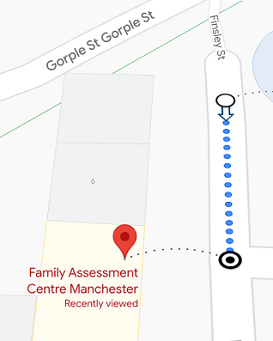
On arrival at Finsley house you will complete PEEP plan (Personal Emergency evacuation plan). This will be completed within 48 hours of you arriving at Finsley House. Within 24 hours you will also have a fire drill staff will explain this process to you and inform you that this will be happening.
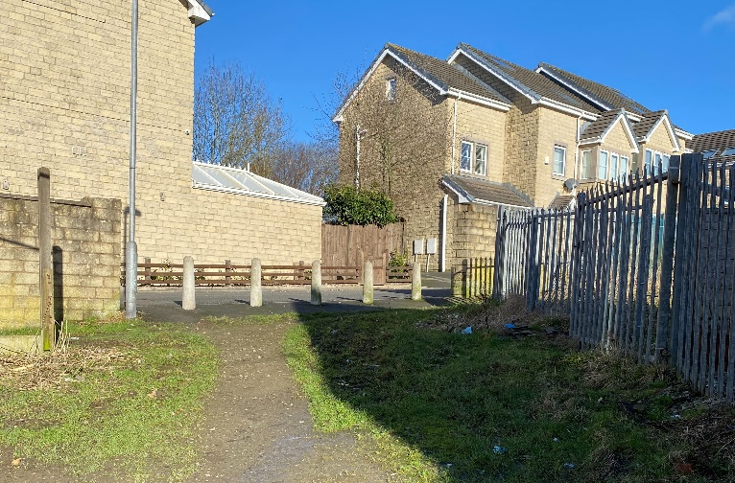



Kaleidoscope Assessment Services
Record of Complaint

At Kaleidoscope, we recognise that it can sometimes be difficult to make a complaint however at Finsley House, we encourage you to make a complaint whenever you feel it is necessary
If you have a complaint, you can complete this form and hand it to the Centre Manager, who will respond in writing to you within 24 hours of you making your complaint
All written complaints will be investigated and you will be responded to within 2 working days. Within this letter we will also explain to you what action, if any, has been taken, or will be taken. If for any reason, due to the nature of the complaint that a longer investigation is necessary, you will be informed in writing and given an explanation as to when we hope to resolve the complaint. If you need any support in completing this complaints form, you can ask a member of the team, whom you feel comfortable with to assist you. However, they can only write the words that you say, to record the complaint.
You may also speak directly to the Responsible Individual, James Broadfield if you email him on J.Broadfield@familyac.co.uk or alternatively call OFSTED on 0300 1231231.

Name:
Contact details:
Summary of the complaint: (Please record, as detailed as possible, what your complaint is and if you can, record the date and the time of the incident or interaction, which you want to complain about)

Signature:
Date:

We want the parent to tell us if they think we are doing something wrong or are acting unfairly in some way. Should residents wish to make a complaint, they may do so by approaching a member of staff in the first instance, or their keyworker or a member of management.
Parents are provided with a complaint from which can also be given to the centre manager who will respond in writing within 24 hours where practicable of the making of a complaint. All written complaints will be responded to within 2 working days and an explanation as to any action required to take will be detailed. If for any reason it requires a longer investigation the parent will be informed in writing.

If there are any complaints that wished to be made regarding the Centre Manager/ Responsible Individual these issues can be investigated by the independent social worker (Markel Care Consultancy).
Carepractitioners@markel.com
Children’s Commissioner for England
Children’s rights commissioner - Dame Rachel de Souza
Sanctuary Building
20 Great Smith Street
London
SW1P 3BT
0207 783 8330
Info.request@childrencommisioner.gsi.gov.uk

Contact Number - 020 8730 6001
Contact details for Ofsted;
Piccadilly Gate
Store Street
Manchester
M1 2WD
0300 123 1231
enquiries@ofsted.gov.uk or
70 Petty France, London SW1H

Useful Contact details
These are people you can contact if you feel you need outside support for any reason.

Kaleidoscope Assessment Services Burnley: 01282 454576 Manchester: 0161 460 8266
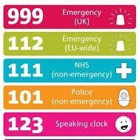
OFSTED: 0300 123 1231
Child line: 0800 1111 - 24 hours
Responsible Individual, James Broadfield – J.Broadfield@familyac.co.uk
St Peters Centre 42 church street BB11 2DL. Tel: 01282 805920

Burnley Registry Office Tel: 0300 1236705

Lancashire Police: www.lancashire.police.uk nonemergency dial 101 Emergency 999

Briercliffe GP Surgery: 01282 911410

Health Visitor: Charlotte Kay Tel: 03002470041/07816 334094

Briercliffe Road Dental Practice: 84 Briercliffe Rd, Burnley, BB10 1UX Tel: 01282 415 104

Burnley Register Office: www.lancashire.gov.uk 30 Todmorden Rd, BB10 4AB 0300 123 6705

To self-refer back to peri natal: 0300 0290500 To speak to someone: 0800 915 4640 Or text “HELLO” to – 07860 022846 for support via text.

Food Banks with BFCitC: Community Kitchen: 01282 704716

Lancashire County Council Youth Zone: talkzone@Lancashire.gov.uk Text 07786511111, Call
Lancashire Mind: 01257 231660, admin@lancashiremind.org.uk

Minds Matter (NHS mental health services for 16yrs +) Burnley: 01282 657268
Mental Health Helpline: 0800 915 4640

Local amenities

Finsley House is located in Burnley, we have a shopping centre, market and all the supermarkets that are only a short bus ride away!














We hope you enjoy your time at Finsley House! 😊

