WELCOME
To
Kaleidoscope Assessment Services


Parent’s Guide (EASY READ)

Contents

- Meet the managers and social workers
- Your flat
- What do I need to bring?
- What we provide
- Local Shops
- Weekly Planner / Events
- Identification
- What do we do?
- The 3 Stages Of Assessment
- Assessment Tools
- What Are We Assessing?
- The Freedom Programme
- CCTV
- Visitors
- What Is An Advocate?
- Direct Work / Parenting Sessions
- Expectations
- Fire Safety
- Complaints Procedure
- Useful Contact Numbers
- Previous Family Feedback

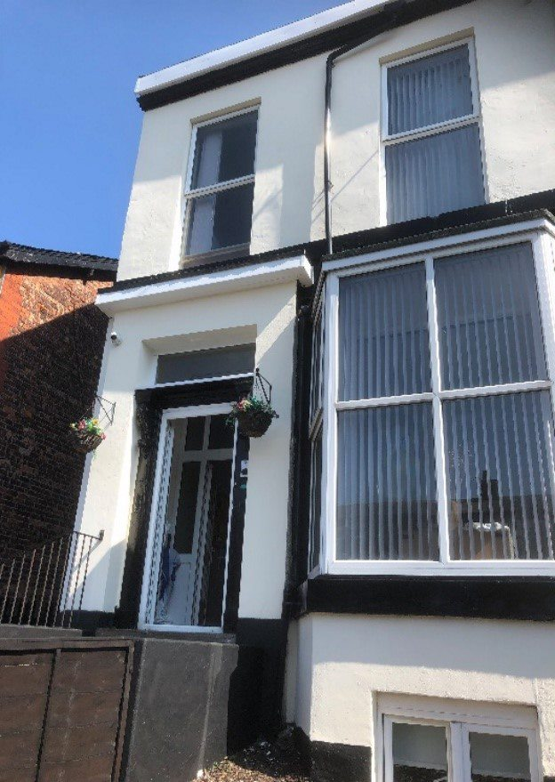
881 Chester Road
Stretford
Manchester
M32 0RN

- Managers and social workers

Registered Manager – Alice

Alice is the Registered manager at Chester Road. If you have any grumbles or feedback, don’t hesitate to chat to Alice. Alice will do her best to make sure your placement with us is as supportive and progressive as possible.

Social worker –Trinity
Trinity is our assessing social worker at Kaleidoscope Assessment Services, based at Chester Road, Trinity will support you throughout your assessment, completing social work sessions with you and write up your report.

James Broadfield – Responsible Individual

"Hi, I'm James Broadfield. I'll be at the centre once a week to help you and your family. I'm here to support you during your stay. If you have any worries or if something's not right, please come and talk to me. I'm a good listener and I'll do my best to help fix any problems. My job is to make sure you feel safe and comfortable. If you're unhappy about anything, big or small, just let me know.”

- You will have your own bedroom, and share communal areas, which include:



living area



Kitchen


Bedroom with cot

Bathroom


- What do I need to bring?























- What we provide:









- Local Shops
We have multiple shops nearby for any shopping you may need.
There is also a retail park about a 15 minute walk from us and you are also able to have groceries delivered to the unit. You will complete a weekly planner each week which gives you the opportunity to plan the week ahead, making sure you prioritise your child’s needs and that you have enough groceries for the week.








It is encouraged you bring the basics (bread, milk, tea/coffee etc) so you settle in on your first night.




- Weekly Planners / Events
Every week, Staff will complete a weekly planner with you, to help you plan for the week ahead. You will also complete a weekly play session with our in-house play worker, who will explore different ideas around play and stimulation with you and your baby/child. A weekly planner will look like this:
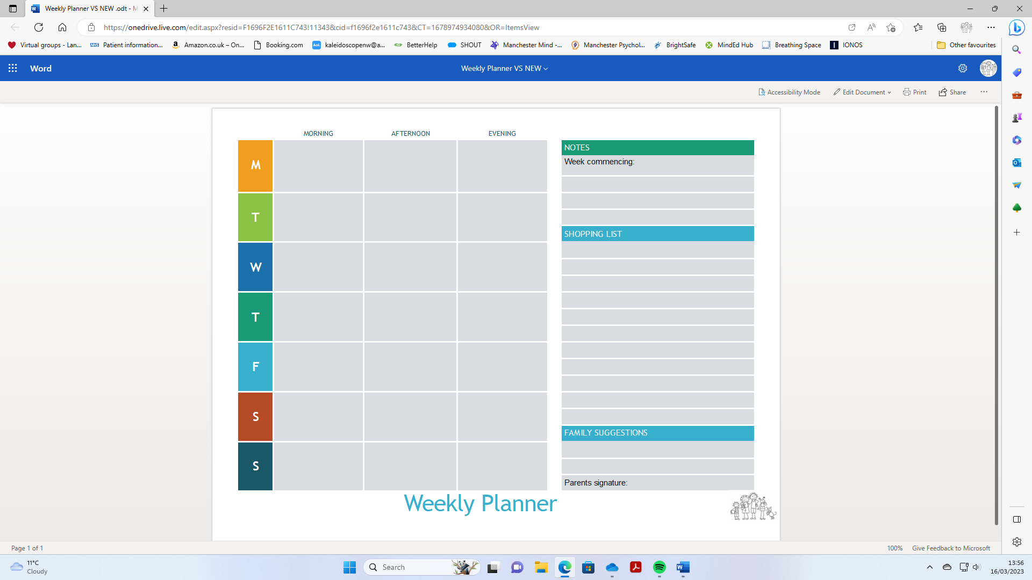

- Photo ID
Bring photo identification with you as you will need this to register at our local GP surgery or Library.


If you are unsure of anything or have any questions then you are welcome to contact us prior to your arrival on 0161 4608266.

- What do we do?

We carry out 13-week parenting assessments – This works out at just over 3 months. This can be extended by the placing local authority if requested, however we do not offer shorter assessments. The social worker will read through the reports with you and ask for your feedback before sending it to the Local Authority.


First 4 weeks

Mid way point At this stage, You will
receive your

first assessment report at week 6.
Final 5 weeks At this stage you will receive your final report at week 12


We support and guide parents to be able to parent their child in a safe and loving environment. We want families to be as comfortable in our unit as they would feel at home.


Kaleidoscope proudly accommodates families of all ages, genders, and sexual orientations. We can accommodate families with up to 2 children aged up to 5 years and this includes couples, single parents, grandparents or guardians.

- The 3 stages of assessment


Full Observation
This is where you will be observed, in person, for all care tasks of your baby.

This is the highly supportive stage of the assessment.
You must complete care tasks in the lounge,
Where there is a buzzer.
You must buzz If you are about to
- change your baby’s nappy
- make them a bottle
- wash or sterilise the bottles
- administer medication to your child
- bath / top and tail your baby
you will be expected to buzz for staff so they can come and observe.
Staff will need to supervise any time outside of the centre with your child, such as going to the park, going shopping, going for a walk e.t.c…
You will be given feedback on the observations and support and guidance if needed. Staff are here to help and support you in this time. If you are struggling with any area’s of parenting, Staff will be available 24/7 to assist you.
This stage is usually for the first 3-4 weeks’ (dependent upon observations and a discussion with the placing Local Authority) and we will then hold a 4 week review meeting, where we will discuss you moving onto stage 2!


Partial Stand Back

If you have demonstrated consistent, safe care in your observations, direct observations will be withdrawn.
This gives you the opportunity to be more independent in your parenting and the care tasks are monitored via CCTV.

This gives you the opportunity to demonstrate your ongoing care of your child without intensive supervision.

At week 8 another review is held, and if in agreement by the local authority, discussions are had about moving on to the next (and final!) stage.
You will still be observed in the community, unless discussed otherwise.



Full Stand back

If agreed by the local authority, You will now be able to go out into the community, unsupervised, with your baby independently to community groups and other agreed outings.






- Assessment Tools
Before your assessment can start, your local authority will need to send us a “Letter of Instruction”. This may sometimes be seen in documents called LOI.
This will be a document stating what kind of assessment they want completing with you and your child/ren and what areas they would like us to highlight in our direct work sessions with you. The sooner we receive this document the sooner we can start your assessment.
Parent Assess
Parent assess is the framework we use to assess all parents when they are at the centre.
About the Framework
Parent Assess is a framework developed for assessing parents who have learning disabilities and other additional needs within childcare proceedings. It addresses both the emotional and practical aspects of parenting and seeks to identify both the strengths and concerns. The traffic light system means the assessment outcomes are measurable and easy to read.
The framework can be used where children remain with their parents or where the children have been placed in foster care and supervised contact is in place.
Parent Assess uses a number of specific visual tools. Video feedback is an important element to help the parents develop their skills.

Our in-house social worker will look at your personal history, views and attitudes toward parenting, understanding of child development and your child’s needs, your willingness to seek help and support and who forms your support network.
WHAT ARE WE ASSESSING?
Kaleidoscope are asked by the local authority to assess your parenting.
This means your skills in looking after a baby, your knowledge about what they need and your ability to give them what they need until they are grown up.
We are not looking for 'perfect'. The local authority are thinking about your child's safety and the assessment is to see whether you are able to keep your child safe.
We are looking at if you are able to, at a minimum:
- meet your children's health and developmental needs
- put your children's needs first
- provide routine and consistent care
- acknowledge any previous issues or problems and engage with support services offered to you.

Whilst you are at Kaleidoscope, We will:
- support, guide, listen and talk with you
- observe how you care for your baby 24/7, including in the community.

All assessments are different, but they all follow the same stages.
We provide you with weekly appraisals, which give us a chance to highlight the positive observations we are seeing whilst highlighting any worries / areas of concern / changes we need to see.
If staff feel that you are struggling / unable to maintain clean/ safe living conditions for your family, staff may prompt you to clean / tidy your flat. Staff may also need to take pictures of your flat to use as direct work around cleaning and safe home conditions. These may also be sent to the local authority. As a last resort, if you do not keep your flat to a clean and safe standard, for the safety and wellbeing of your child staff may have to tidy / clean it themselves.
All reports will be read through with you by the social worker, and feedback will be requested from yourself on your report before it is sent to the local authority.



The Freedom Programme is a domestic violence programme which was created by and is run by Pat Craven and evolved from her work with perpetrators of domestic violence.
The Programme was primarily designed for women as victims of domestic violence, since research shows that in the vast majority of cases of serious abuse are male on female. This may be requested by your local authority.

- CCTV at Kaleidoscope


The centre operates 24-hour CCTV recording, all staff are trained in safeguarding children and how to respond in line with our local Safeguarding Children’s Board.
The cameras are situated in communal areas such
- front and back entrances
- hallways and stairways
- living room
- kitchen
- bedroom (only over baby’s cot)

Your baby is required to remain on CCTV at all times unless there is a staff member physically present until you have progressed and evidenced throughout your assessment that you are able to parent your child safely and keep them free from harm.

We offer the following levels of CCTV monitoring within the centre:
- Full CCTV monitoring. (for up to 2 weeks)
- Intermittent CCTV monitoring of 30 minutes/60-minute intervals.
- Random CCTV monitoring.

The level of CCTV monitoring will be agreed before the placement will start and will be discussed in a pre-placement meeting. Here you will be able to ask any questions you might have about CCTV. The level of CCTV monitoring can change during your placement but this will be discussed with you and your child’s social worker before any changes take place.

We know it can be a scary thought being on CCTV so we want to make sure you feel as comfortable as possible. We may ask you each week during your appraisals how you are feeling about the CCTV.



- Visitors

We understand the importance of being able to see your friends and family whilst being here. Visitors are permitted on the basis that they have been approved by the placing local authority.

We require at least 48 hours notice and visiting can last 2 – 3 hours, twice a week, unless discussed otherwise with the local authority.

Your views and opinions matter.
We value the feedback given from you and other families staying here.
We will hold monthly resident meetings, which gives you and the other families the opportunity to discuss any worries, concerns and make any recommendations and feedback as a group discussion.
We will also ask you for feedback on a one to one basis which gives you the chance to give personal feedback.
If at any point you feel that your wishes and feelings aren’t being listened to and you want to make a complaint, do not hesitate to fill out a complaints form. You can find one of these in your welcome pack, or alternatively you can ask a staff member for one.




- What is an advocate?
An advocate is an independent expert who can help support you in navigating the social care system.
As well as provide practical advice, they can work on your behalf to ensure all the rules are being followed correctly, and you’re getting everything you’re entitled to.
If you do wish to have an advocate, then you can speak to your social worker who can put a request in for you.
Alternatively, a member of staff here can support you with this. You can also make a self-request for an advocate if you wish.

- Direct work and parenting sessions

Kaleidoscope is a place where you will be supported and given guidance on how to parent your child in the safest way.

Staff will do direct work sessions with you every evening on different areas of parenting.

You can also request certain subjects, if you feel you are struggling in any area. For example, If you do not feel confident bathing your baby, that’s okay! The staff here are more than happy to support you with this and offer guidance so that your confidence builds!

Parenting sessions will be held by our social worker, where you will chat about your progress, what lead to you being assessed, your past, present and your future.

In our direct work sessions, we will cover different area’s – such as




Cooking

Making sure you have healthy meals for yourself and your children, or preparing for your child to wean.

Don’t worry if you are unsure of how to cook as we can help you do this. We will hold cooking / baking sessions and offer group sessions with other families too.




Housework

Housework, Hygiene, making sure you have a clean flat to live in and are aware of the risks and hazards of having an unclean/untidy flat.

Highlighting the importance for your child so they have a clean safe environment to grow and develop in.



Home Safety

Making sure your children are safe and your knowledge of potential dangers in and around the home and how to prevent or minimise any risks.



Child Development

How to play and talk to your children, learning the different developmental milestones and stages of development.



Behaviour Management

Managing Behaviour, how to deal with conflict, tantrums, stress, having family rules and praising your children for good behaviour


Routines

Having day to day routines for your family, the importance of this and the benefits for your family.




Budgeting

Money, saving and managing your finances effectively whilst prioritising your child’s needs.



Family Dynamics/Relationships

Your family, Your support network and people in your family. How they get on with each other and the impact behaviours can have on yourself and your child/ren.

We will tailor the teaching we offer to your individual needs based on the information we receive about you, prioritising the areas you need help and support the most.

You can also discuss any areas you can identify yourself where you feel you need help and support with.



- Be respectful towards staff
- Be respectful towards the other families
- Be honest and open with staff
- Sign in your medication as soon as you get it
- Be responsible for your own valuables
- Adhere to NHS / Safe Sleep guidelines.
- Refrain from lending / borrowing items from other residents.
- Keep the living spaces clean and tidy
- Report any broken items / faulty furniture / maintenance issues.
- Do not bring any alcohol or substances into the unit.
- Do not smoke or vape inside, use the smoking area situated in the garden and dispose of cigarette butts in the bin provided.
- Keep fire exits clear (No storage of prams / belongings in front of fire exits)


- Fire Safety

On your arrival you will complete a PEEP plan (personal emergency evacuation plan)
A member of a staff will complete this with you.

Every Friday at 11am a fire alarm test will be done. This will sound the alarm. If you hear the alarm sound at any other point, you must evacuate the building as soon as possible. The fire exits are

- Front Door (Exit through the front door, then follow the street to Canute Rd.)
- Back Door (exit through the gate, down the path)
- Basement Flat Window (Use step to exit in emergency)

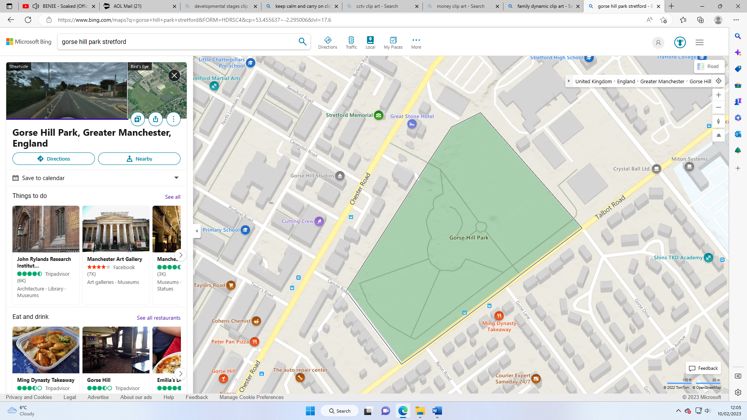
Once you have exited the building, head towards the entrance for Gorse Hill Park, shown below:


Kaleidoscope


Gorse Hill Park Entrance



- Complaints procedure



If you are unhappy about anything whilst you are here.

Staff are available 24/7 for any worries or concerns you may have.

If you feel that you can’t talk to them about your problem, Or you feel that your problem has not been dealt with, you can talk to -

The Manager, Alice.

If you are still not satisfied with the response, you can contact the Responsible Individual, James, on the following number:

James Broadfield

Tel: 07817780799

If you still feel unsatisfied with the outcome, You can contact OFSTED on
0300 123 1231.
70 Petty France
London
SW1H 9EX

Children’s Commissioner for England
Children’s rights commissioner - Dame Rachel Desouza
Sanctuary Building
20 Great Smith Street
London
SW1P 3BT
0207 783 8330
Info.request@childrencommisioner.gsi.gov.uk

- Useful Contact Numbers

Kaleidoscope Office: 0161 460 8266
Child Benefits: 0300 200 3100
Cohens Chemist: 0161 226 3249
Community Midwives: 0161 276 4458

Children’s Commissioner, Dame Rachel de Souza: 0207 783 8330
New Moon Taxi: 0161 864 1010
NHS Direct: 111
Non-emergency police: 101
North Trafford Group Practice: 0161 865 5556
North Trafford Health Visiting Team: 0161 912 5567
Ofsted: 0300 123 1231
Royal Manchester Children’s Hospital: 0161 276 1234
Seymour Grove Health Centre: 0161 848 7563
Tax Credits: 0345 300 9300
Trafford Domestic Abuse Service: 0161 872 7368
Trafford Drugs and Alcohol Service: 0161 358 0991
Trafford General Hospital: 0161 748 4022
Universal Credit: 0800 328 5644
Cry-Sis Helpline: 08451 228 669
Manchester Mind: 0161 769 5732
SHOUT: 85258
Manchester Psychological Wellbeing Services: 0161 2263871
Trafford Registry Office: 0161 912 3026




- Feedback from previous families


We are delighted when we receive positive feedback from our parents. It tells us where we are getting things right, which help us to continue to improve our service.

Parent 1:
“Thank you to all the staff this place is lovely, A job well done with me and my baby, People can live such a happy life if you tick the boxes and prove yourself, It’s not easy going through the assessment bit it’s worth it in the end for a happy life with your baby xxx “

Parent 2:
“Even though I was worried when I found out we were coming here to stay for 12 weeks all the staff have made me feel welcome and have all been helpful & not judgmental like I thought they would be in fact it has made me feel very safe & boosted my confidence.”

Parent 3:
“Being here has been invaluable for giving me and my son the best start possible, our bond is so close and everything I do his for him and for my other kids is thought through, like things to benefit his development, playing reading, and even talking to him, even the monitoring at the beginning with what I said to him was wrote down this made me think about the simple little things I did , that would comfort him stimulate him and make our relationship the best I can, although at first I didn’t realise why it was all monitored like it is I can now see why, I have a great relationship with all the staff especially those most involved with us, I feel able to ask and talk about anything, a lot has been brought up personally for me and in the past if someone would have said of me dealing with the issues I had shut myself away from whilst I was here with CCTV 24/7 I would have never believed I could do it in a million years. Being a mother comes naturally to me and I wouldn’t of wanted to address any of the rubbish I had hidden away of fear that I’d not cope, and that I would struggle being a mum again, However it as not at all been negative for me personally or in my ability to be a good parent.
I have talked about my past and because of doing so I really feel positive that I can deal with it and also anything else that may arrive in the future, it really as changed my life, knowing I can live and cope without drink, drugs and a man, as made me strong, happy and I know I will be able to be the best mum possible for my son and all my kids.
I thank every single person that has been part of this process the social workers for giving me the chance to be here to have all this help and enabling me to prove to everyone but mostly to myself that I can achieve anything if I put my mind to it.”

Parent 4
“Being at Kaleidoscope has been an amazing opportunity with great advice if needed. Having the weekly appraisals are great, they let you know what has been going well and what could be done better.
We were very worried about coming here but being here has been great. Friendly staff. It can be very scary at first knowing you are being watched but you genuinely forget”
Parent 5:
“Great support, staff members have always been there for us whenever we needed them”

