Dumbell House

Parent’s Guide

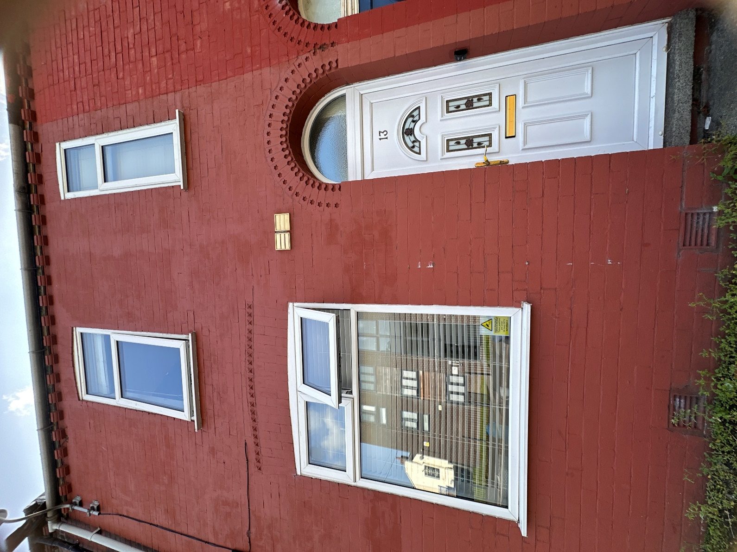


In this handbook you’ll learn…

- Meet The Team
- All About Dumbell House
- Three Stages of Assessment
- Assessment Tools
- CCTV
- What You Need to Bring
- Visitors
- What You Will Learn
- Time At the Centre
- House Rules and Expectations
- Fire Evacuation
- How to Make a Complaint
- Local Amenities

Meet The Team

Joanne Kelly – Registered Manager
“Hi, I’m Joanne, the Manager of Dumbell House. I will be here every day, Monday – Friday making sure everything is in place at the centre. If you have any grumbles or feedback, please don’t hesitate to come and chat to me. I will do my best to make sure your placement with us is as supportive and progressive as possible. You will be seeing me frequently during your stay”
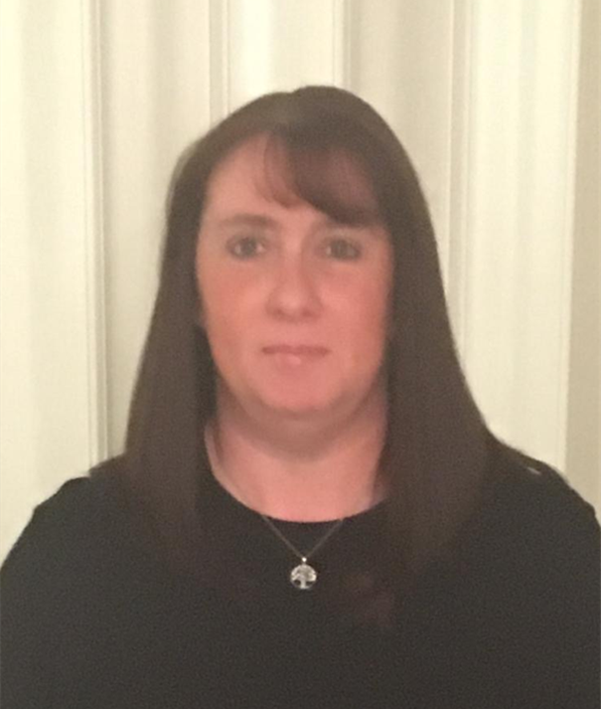
Gill Franklin – Deputy Manager
“Hi, I’m Gill, the Deputy Manager of Dumbell House. I will also be here every day, Monday-Friday with Joanne. I am always willing to support in any way that I can, and I am a great listener. I will be spending a lot of time with you during your stay, and I will do my best to make it as enjoyable as possible.”

James Broadfield – Responsible Individual
"Hi, I'm James. I'll be at the centre once a week to oversee everything at the centre. If you have any worries or if something's not right, please come and talk to me. I'm a good listener and I'll do my best to help fix any problems. My job is to make sure you feel safe and comfortable. If you're unhappy about anything, big or small, just let me know.”

Imogen Dewhurst – Assessing Social worker
“Hi, I’m Imogen and I will be completing your parenting assessment at Dumbell House. You will see me once or twice a week to complete social work sessions and I will be writing your interim and final reports. I will always work open and honestly with you, and if you have any questions about your assessment please do not hesitate to ask.”

Family Support Workers – We have a dedicated and experienced team of family support workers who will be working with you every day, mostly during the evenings, nights and weekends. They will be here to observe, support and offer advice throughout your assessment. All staff at the centre are trained in Paediatric First Aid.




Simi Joey Ugonna




Kay Damilola Moses




All About Dumbell House

Dumbell House is a place for parents to bond with their child/children for 13 weeks. You will be here to complete a parenting assessment, so we can assess your ability to safely care for your child/children.
Dumbell House is a spacious, two-bedroom terrace house which accommodates up to 2 families at one time. You will have your own bedroom and en-suite for you and your family, and share a communal kitchen dining area, playroom/lounge and meeting room. Please respect the communal spaces and clean up after yourself.
Staff are here 24 hours a day to observe and support you in all ways such as offering you advice and even teaching you lots of things you may not know already.
Whilst you are at Dumbell House you will be assessed on how you care for your child and how we can support you and how other professionals can support you. We are here to help you become the best parent you can be. Although it can be scary coming here, everyone wants to help and support you.
This is your opportunity to show everyone that you can keep your child safe and give them everything they need.

Bedroom 1 Bedroom 2
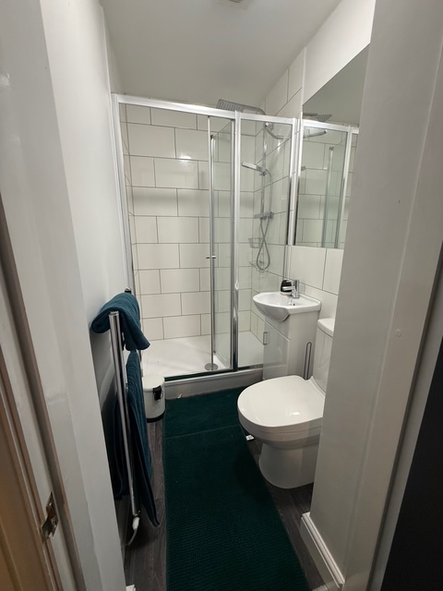
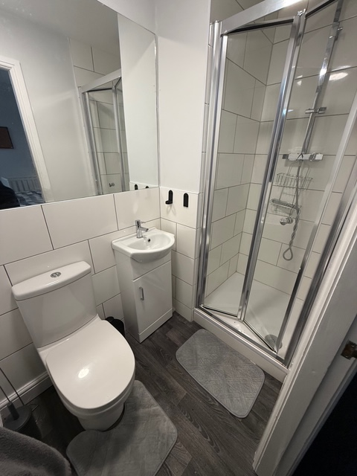
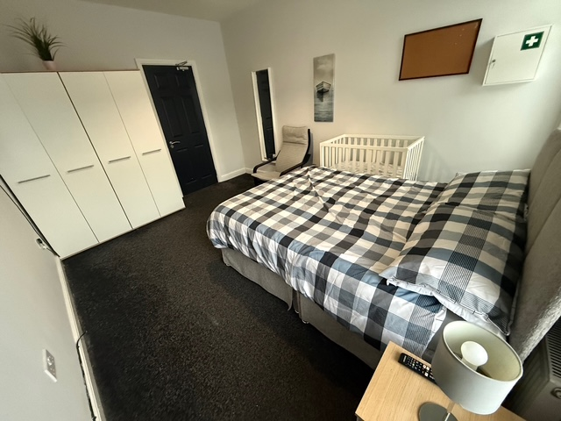
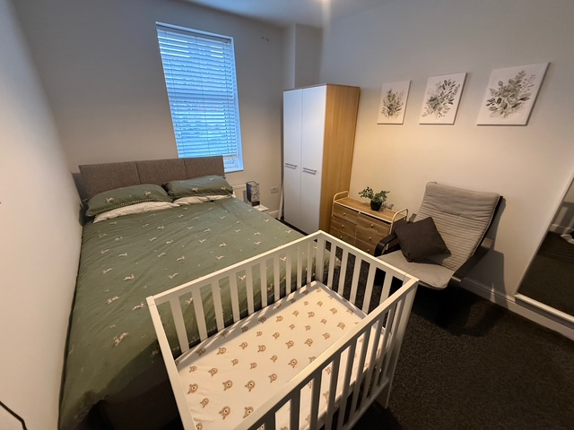
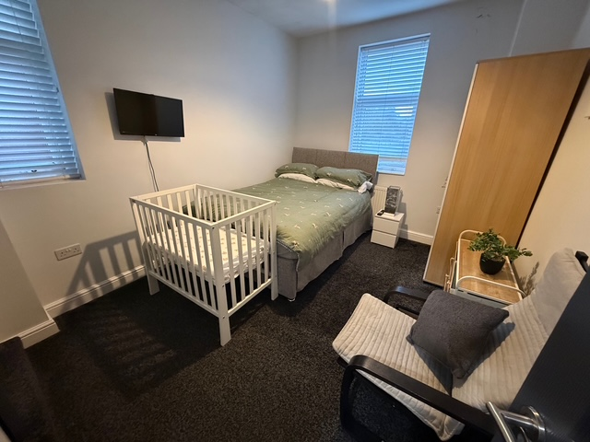
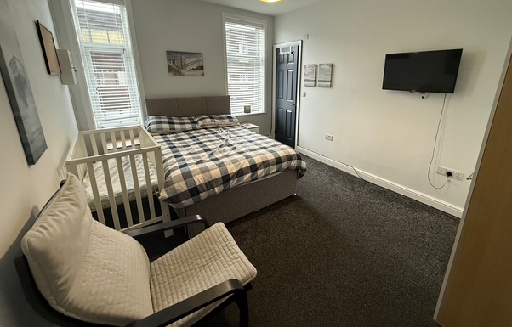

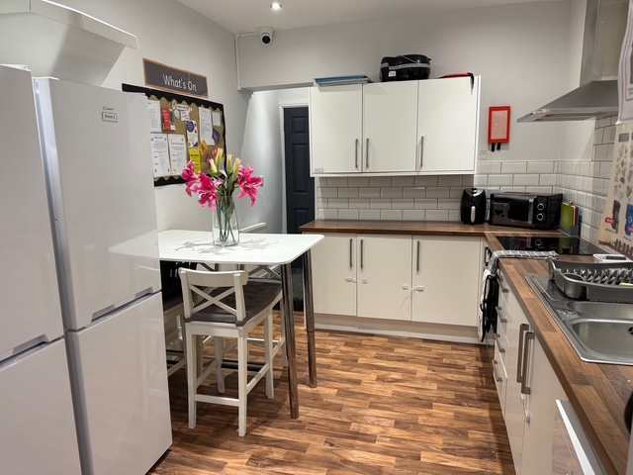
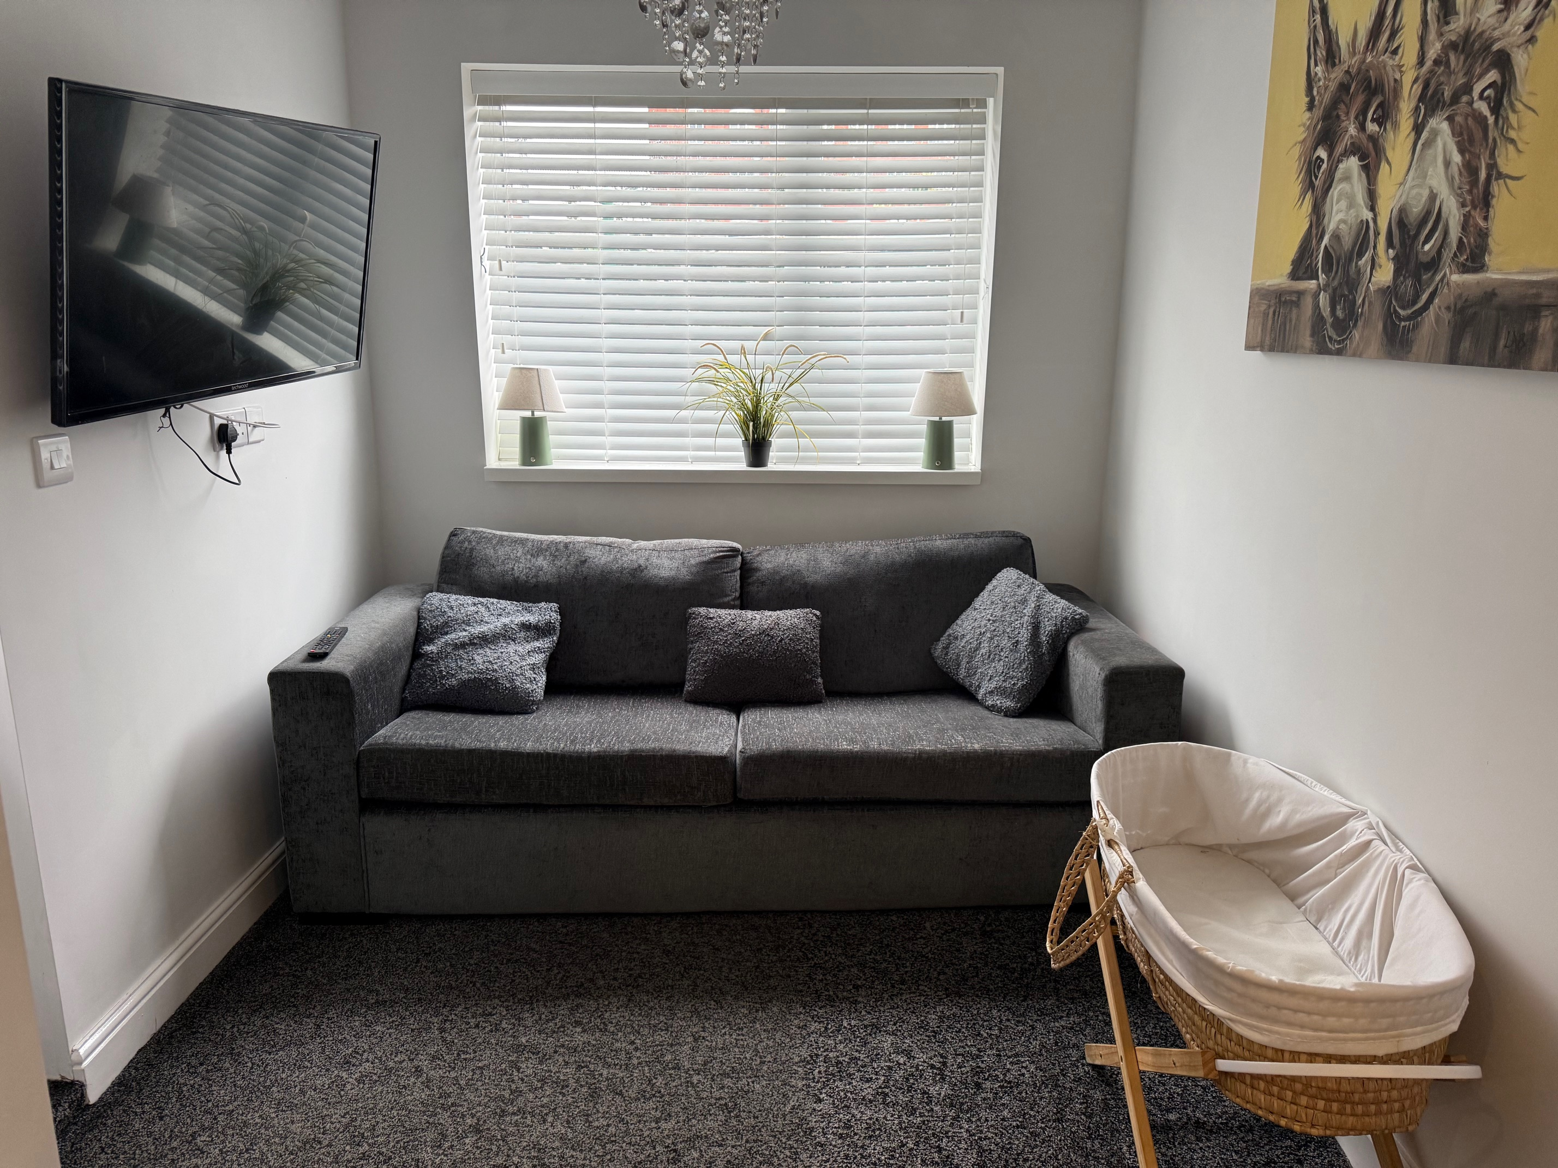
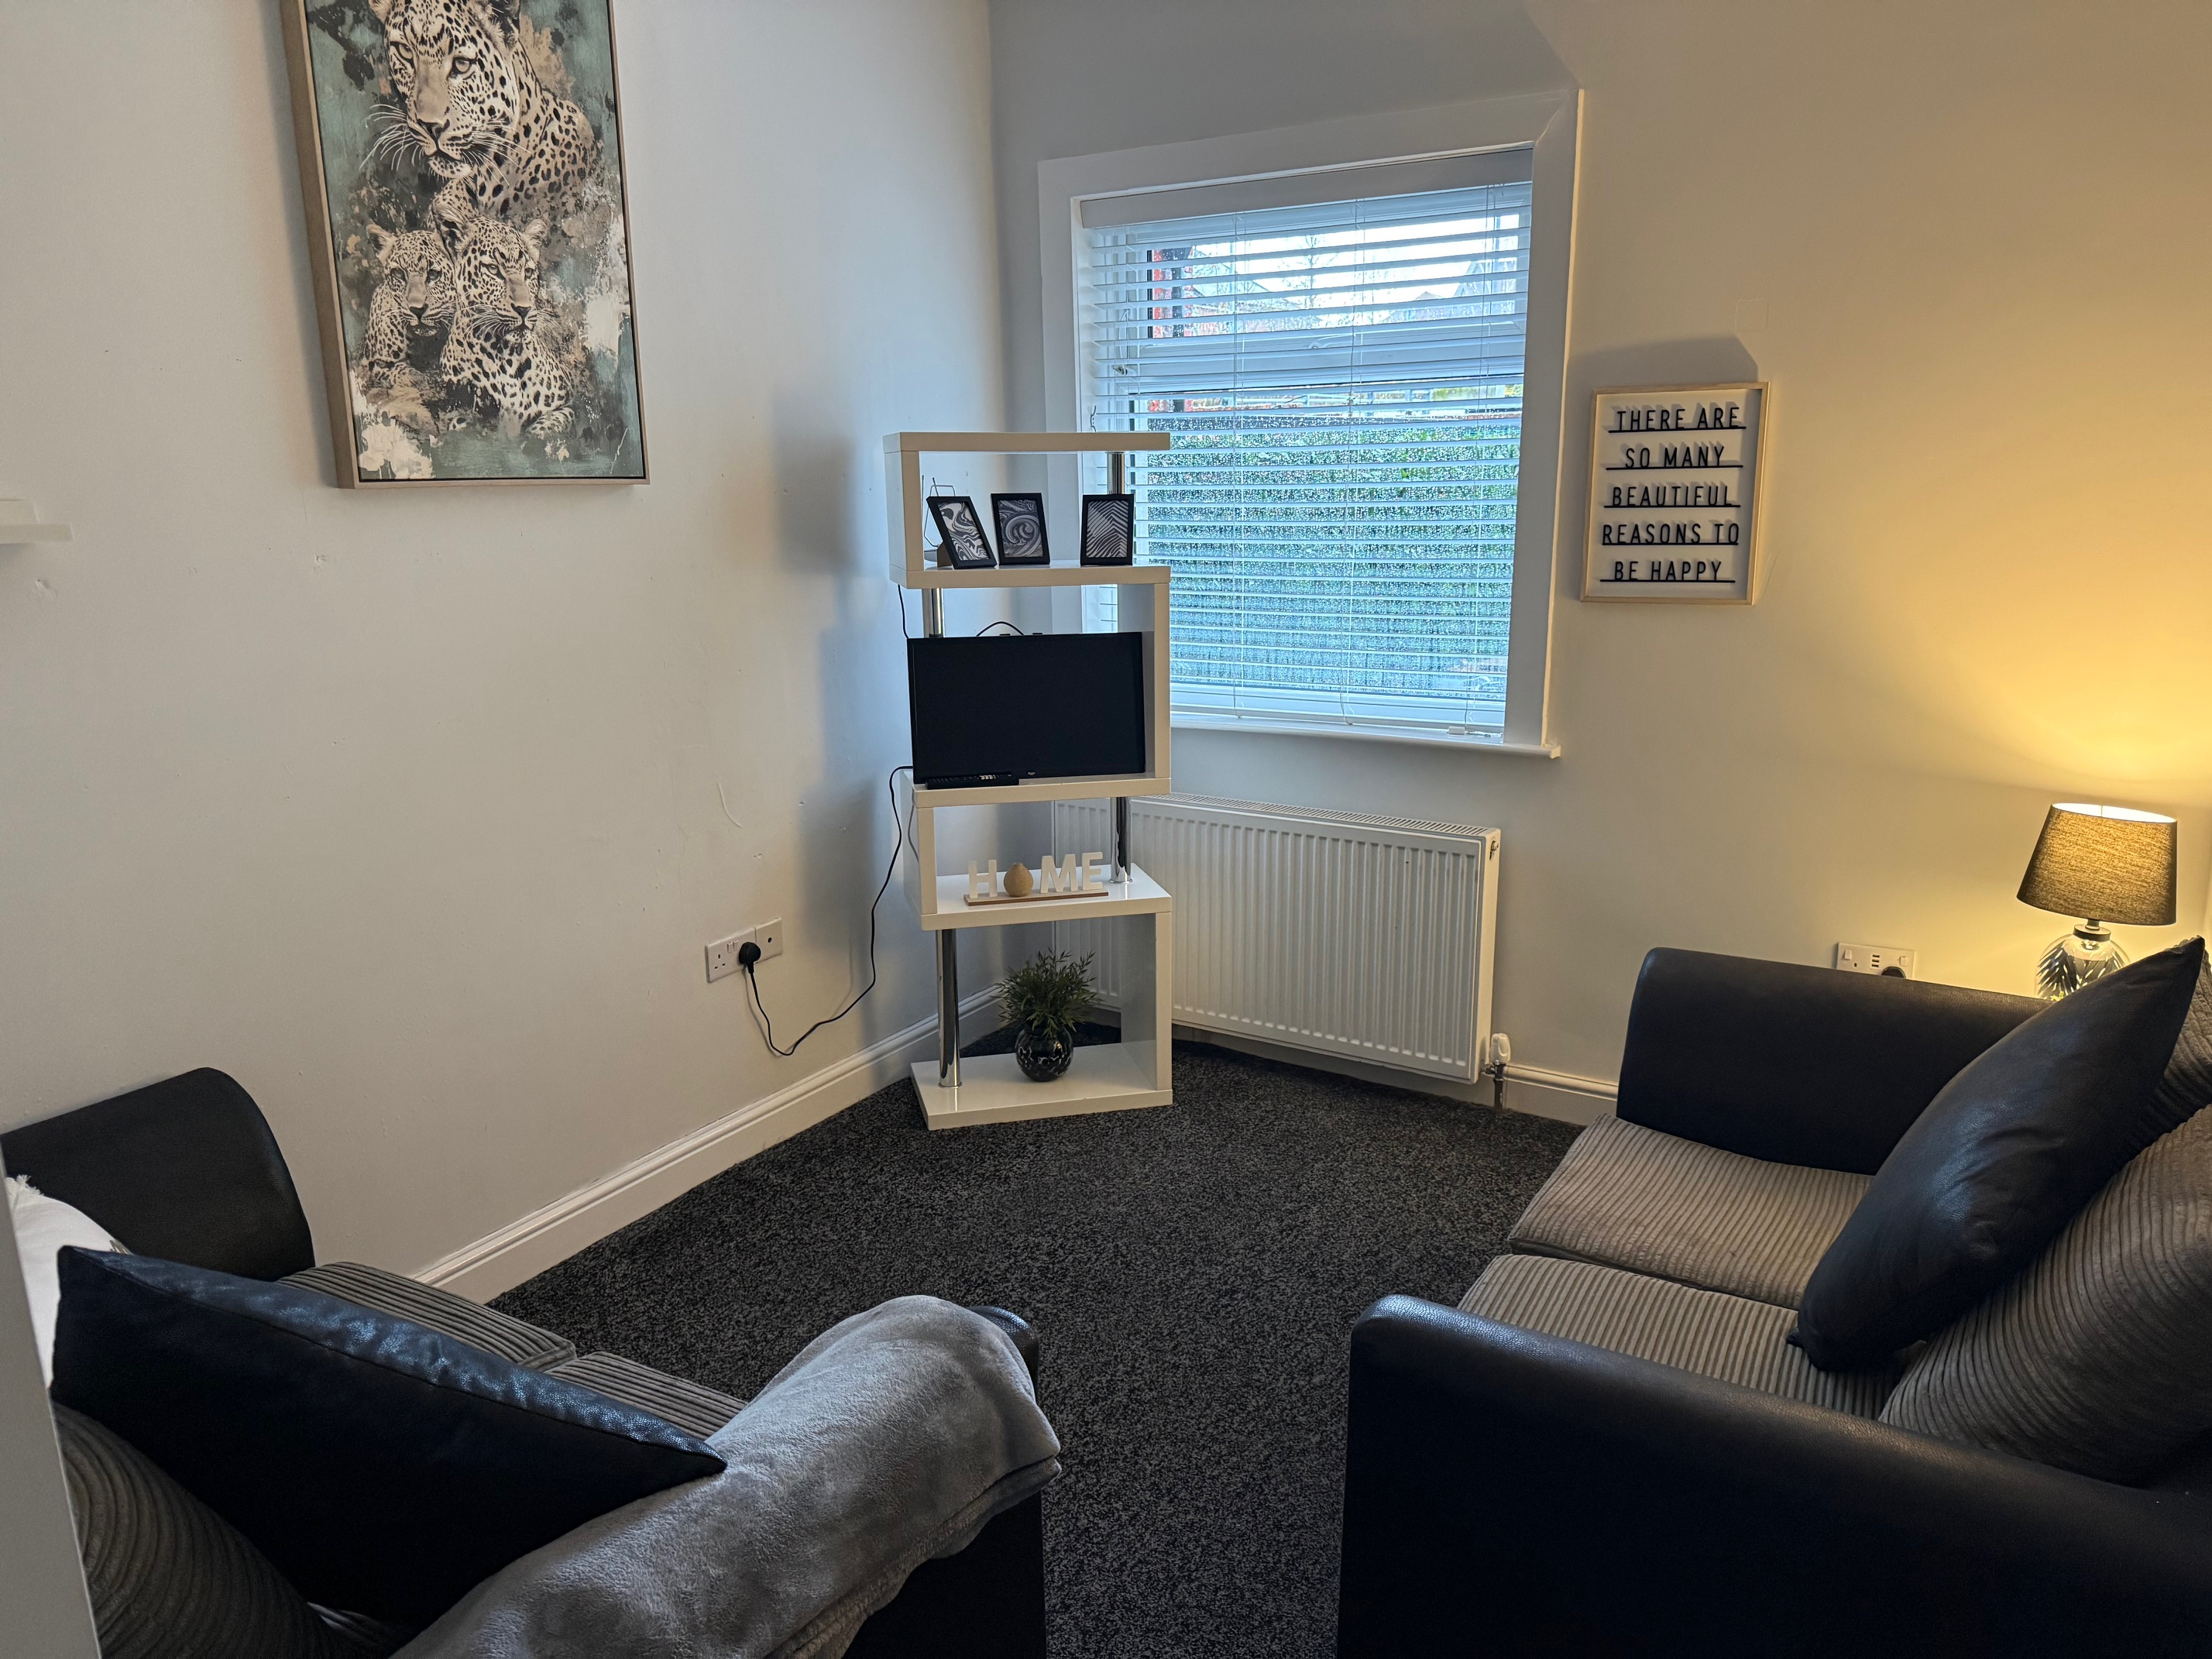
Communal rooms
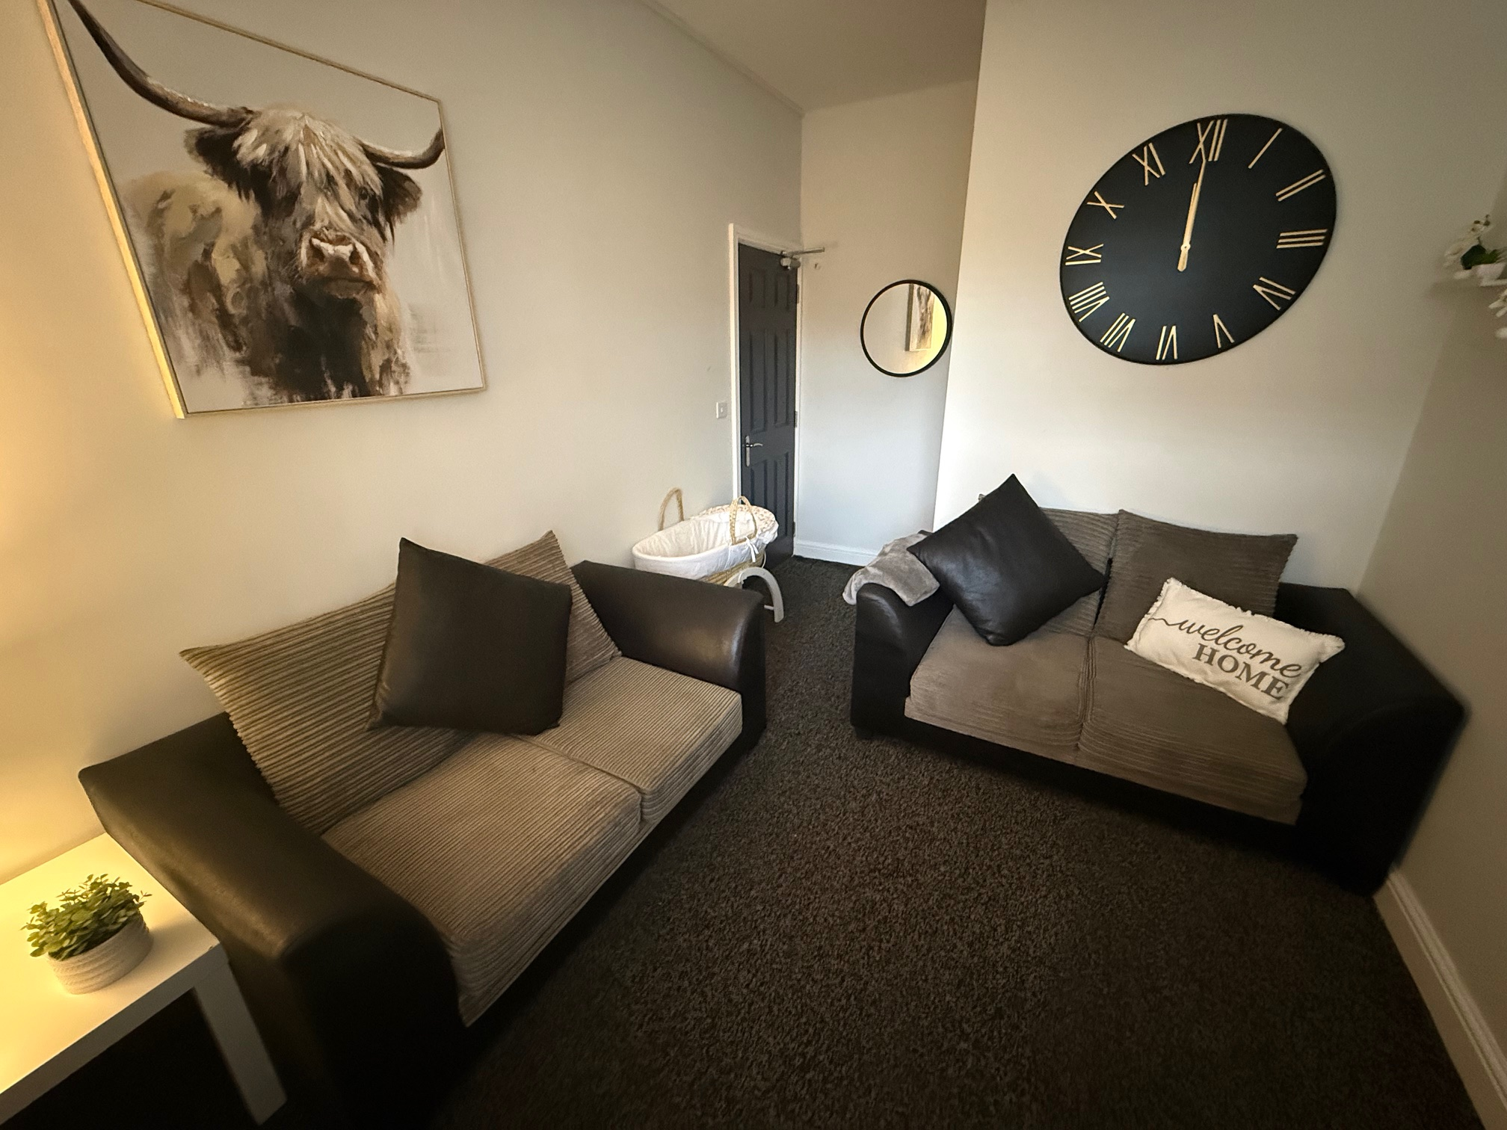
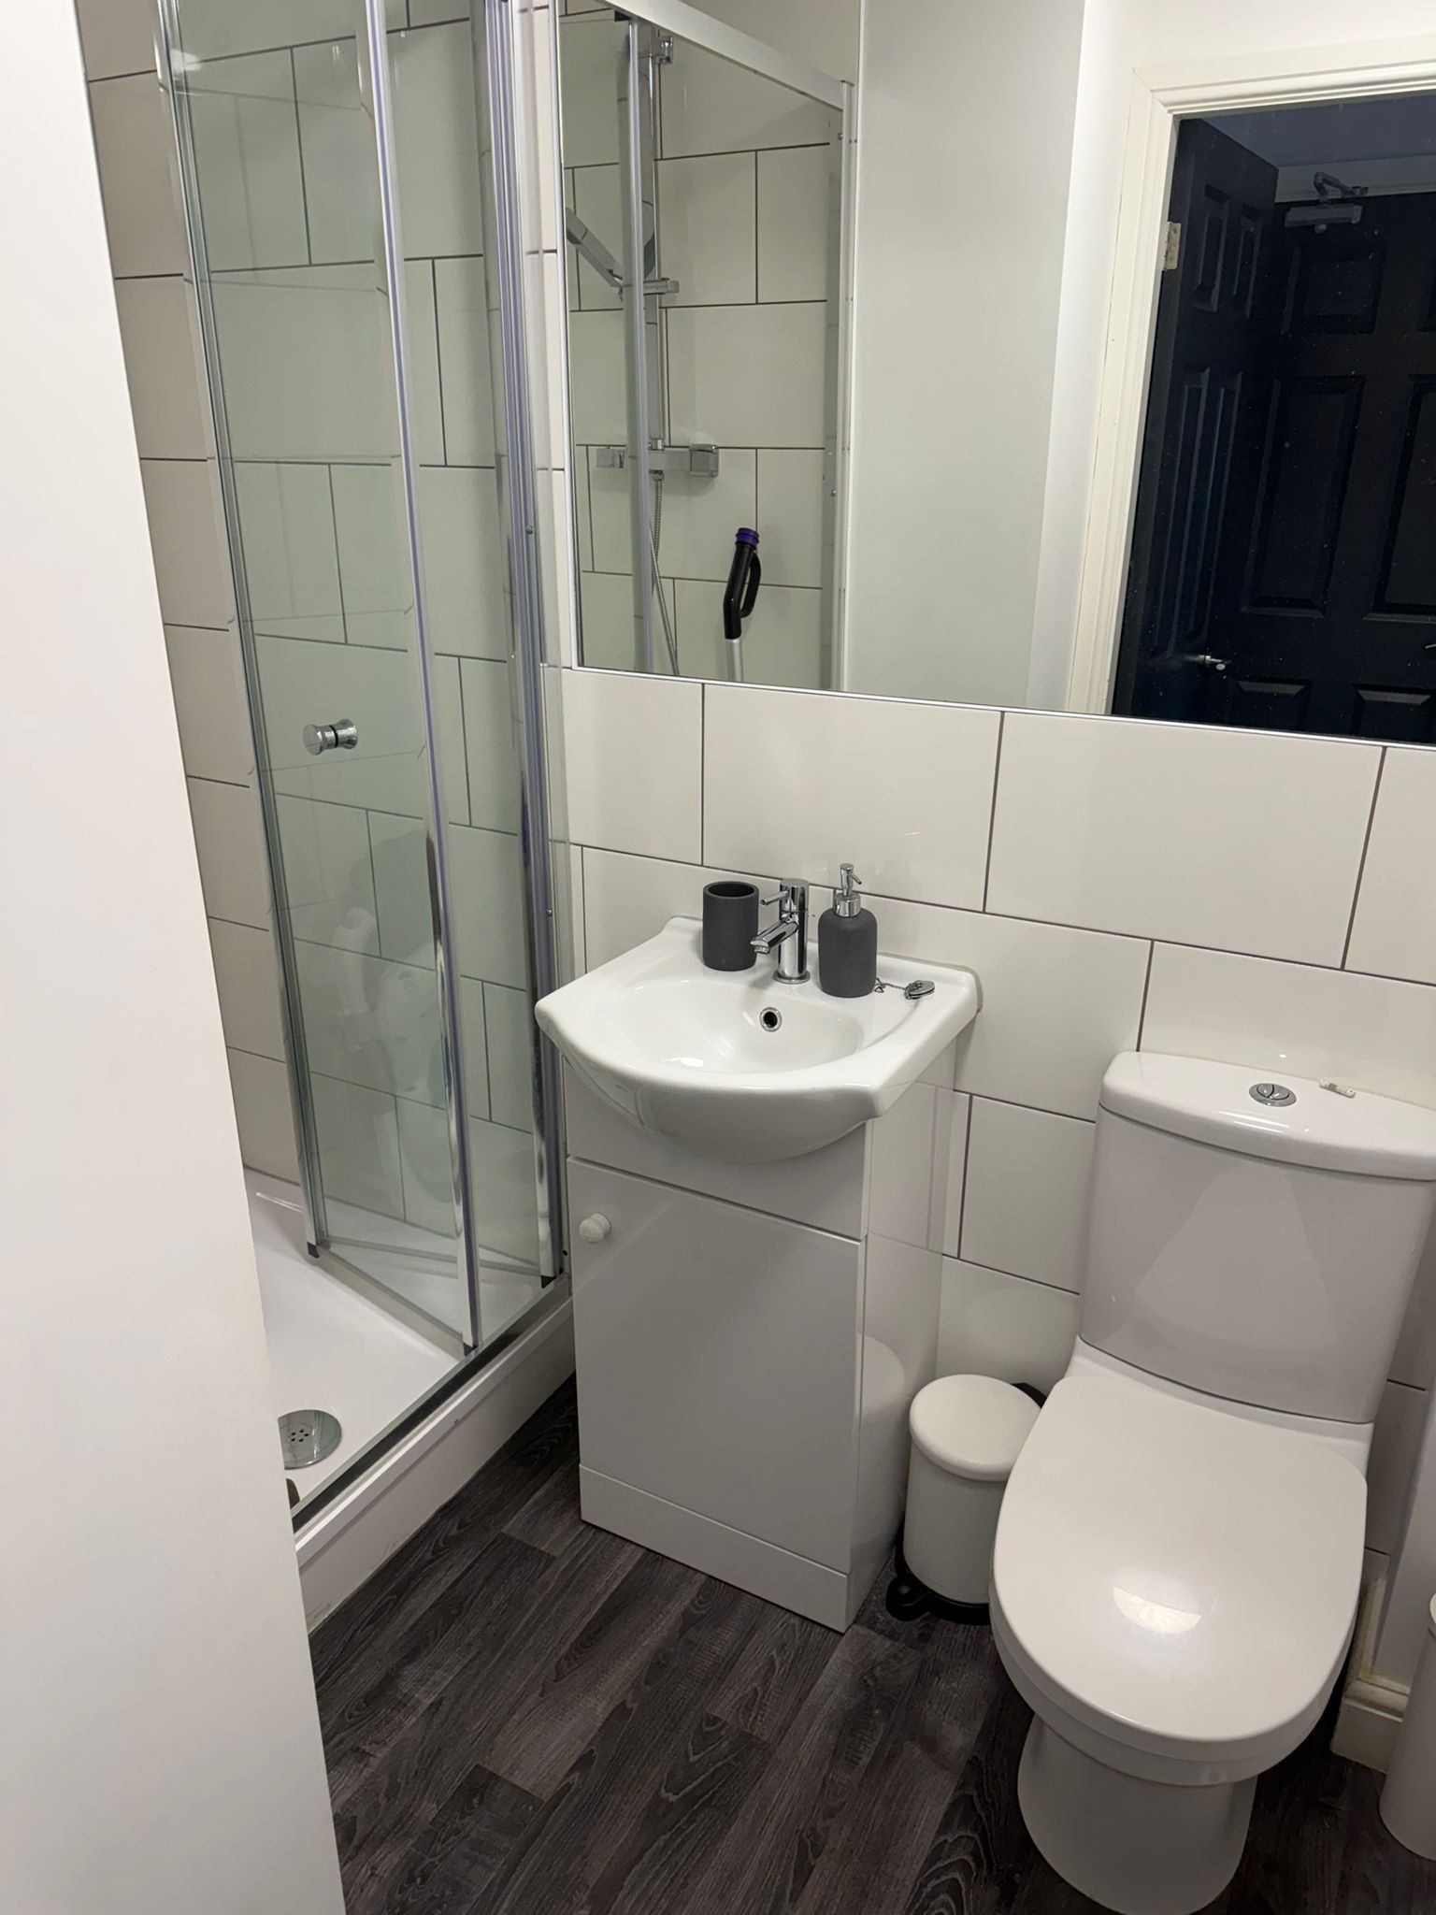
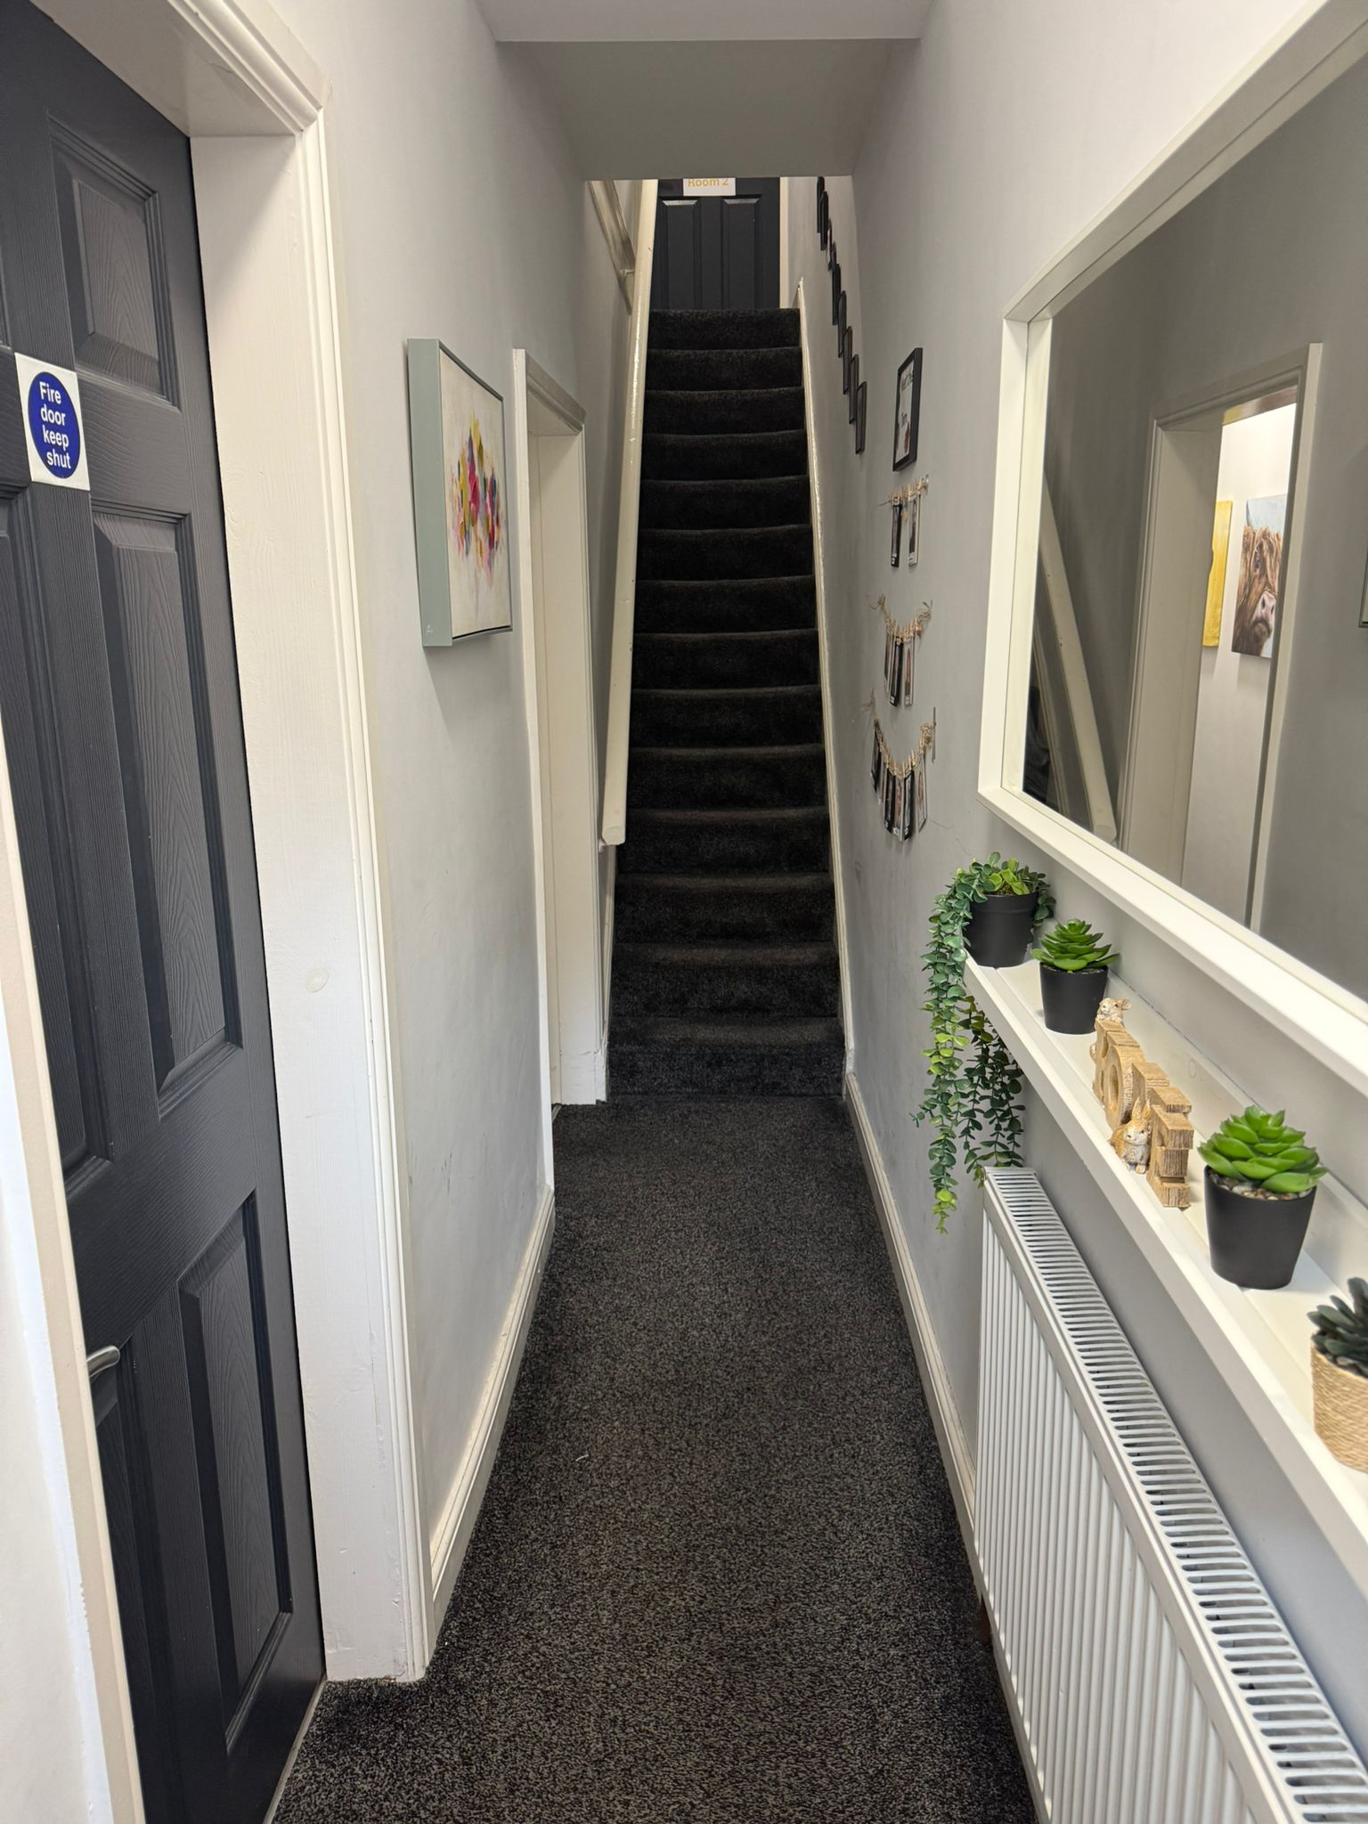




The Three Stages of Assessment
- Full observation
At this point of the assessment staff will attend in person to observe when you carry out any care tasks. These consist of, bottle preparation, bottle feed, nappy change, sterilising bottles, bathing. During this stage, all care tasks during the night will need to be completed downstairs in the communal areas. Staff will also supervise any outings with you and your baby to places such as the supermarket, baby groups etc. This stage can be intense and there will be a lot of teaching and learning. This stage will indicate to us whether you can safely and competently carry out care of your baby without staff prompting or intervention.

- Partial stand back
Following on from Full observations, is the Partial Standback stage of your assessment. If the above-mentioned criteria have been met, e.g. you can prepare a bottle, change a nappy, feed your baby without prompting, in a safe and consistent manner then you will no longer require staff to observe this in person. This would need to be confirmed by our assessing social worker, your social worker and the management team. At this stage, you will continue to go to places such as the supermarket, baby groups, appointments with a staff member.

- Full stand back
Following on from the above, if you consistently meet all your baby’s basic care needs, and you regularly take your baby to baby groups and, in the community, safely, then the final stage is full stand back. During the final stage you will be able to go into the community independently without staff present. We will usually put a transition plan in place so that this can be started gradually and monitored each week. This will be agreed by social workers and the management team. At this stage it will be an opportunity for you to show that you can put everything you have learnt into practice, without staff support.

You will receive your interim/midway report in week 6 of your assessment, and your final report in week 12.

Assessment Tools
Parent Assess Assessment:
Parent Assess is an assessment process that aims to fit the needs of all adults. The assessment works in a traffic light system to help identify what the parent is doing well, what needs work and what is an immediate risk. The assessment allows the social worker to focus on areas of concern to help support and improve their parenting. The assessment has a court version and an easy read parent version, so it is accessible for all. The assessment focusses on domestic abuse, mental health, basic care and parental capacity.
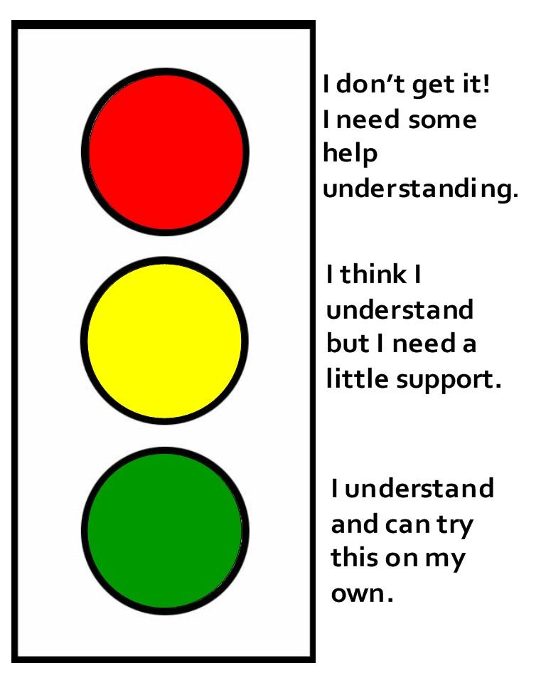
The assessment style is used to:
- Understand the parent’s difficulties.
- Enable the parent to understand.
- Not setting the bar higher. ​
- The child must be central to the analysis of parenting​.
- The parent’s ability to change and adapt must be assessed​.
- The support network must be assessed​.
- Explain the outcome in a way the parent can understand.
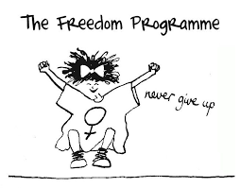
- A simple traffic light system is used to relay views and outcomes.

Freedom Programme:
The Freedom Programme is a domestic violence programme which was created by and is run by Pat Craven and evolved from her work with perpetrators of domestic violence. The Programme was primarily designed for women as victims of domestic violence, since research shows that in the vast majority of cases of serious abuse are male to female. If you are going to be competing the Freedom Programme, then will be requested by your local authority when they place you at Dumbell house. The Freedom Programme sessions are every Thursday at 1pm via Teams.

CCTV
At Dumbell House there will be CCTV in all bedrooms, hallways and communal rooms, except the bathrooms. CCTV is also at the front and back of the building. This is so we can keep everyone safe at the centre. Your child must always remain on CCTV unless a staff member is in the room with you to support you.
It is important that you follow this, not following this rule could result in Dumbell House ending your placement. The CCTV is there to keep everyone safe.
The CCTV cameras and audio remain on and recording 24/7. Your Local Authority will request which level of CCTV is required for you – this will determine how often staff will need to be watching the footage.
There will be a privacy screen covering your bed to allow you privacy when sleeping – you are not permitted to place or hold your baby in the bed at any time. Your baby must always remain on CCTV, and we do not allow co-sleeping.
What You Need to Bring
Please bring all your essential items for yourself and your child. This includes clothes, toiletries, nappies, changing mat, wipes, changing bag, steriliser, bottles, highchair, hairdryer etc.
You do not need to bring any furniture with you – this is all here already. There will be a cot in the bedroom, but if you would prefer to bring your own next to me or moses basket then you are welcome to.
You will need to bring your own pram; rain cover and car seat.
You may keep your phone however we do not give permission for you to record staff or the building.
Whilst at the centre you will be expected to buy your own food, cleaning products and toiletries.
Don’t forget to bring your identification with you so you can register at the GP.

Visitors

Within Dumbell House families are permitted to have visitors but all visitors must be approved by the placing Local Authority. All visits must be pre-arranged with the staffing team at Dumbell House, so we ask families to give us 48 hours’ notice of any visit that may take place. Usually, visitors can stay from 2-3 hours, once or twice a week but this can be arranged to meet your needs.

Time At the Centre
When undertaking a parenting assessment within Dumbell House parents are expected to fully engage in all work requested such as direct work, social work sessions and play sessions.
Especially at the beginning, it can seem like a lot and can be very overwhelming. You may feel like it is getting too difficult, come and speak to staff so we can explain anything and re-assure you. Staff at Dumbell House will be open with you about everything. You will be kept up to date with everything; we won’t hide anything and will work openly and honestly with you. We also expect you to be open and honest with us.
At Dumbell House we like to go on monthly activities to places such as Sealife, Knowsley Safari Park, Smithills Farm, Heaton Park, and many more. If there is anywhere you would like to visit whilst you are here, please let us know. We also have a ‘what’s on board’ which we update monthly with local activities and ideas of things to do as a family.

Observations: (washing/sterilising bottles, preparing a bottle, feeding, bathing, administering medication, nappy changes, body check)
As mentioned, during the first stage of assessment staff will be observing all care tasks in person. It is important we see these so we can support you with anything you need. At first this may be overwhelming, but we just want to make sure your child is safe and you have all the support you may need. Once staff are confident that you can consistently complete these tasks well, they will be observed via CCTV instead. Staff will also complete a body check of your baby every day.
Baths and administration of any medication to baby will continue to be observed in person throughout the 13-week assessment.
Direct work:
Whilst at the centre you will be given direct work to complete with staff – this can be in a variety of forms and covers a range of topics such as childhood illnesses, abuse, impact of alcohol and drug misuse on children, home conditions, self-care etc. This can also be hands-on work such as helping you clean/tidy and cook. Your direct work will relate to the concerns from the Local Authority. You can also request additional direct work if you would like to learn about something that is not on the planner.

Daily logs and Appraisals:

All observations and interactions are recorded on a document called daily logs. These are sent to the Local Authority every week and form part of the evidence of your assessment. Each week you will also be given an Appraisal, which are also shared with the Local Authority – where we discuss the previous week, what went well and what could be better. You will also be asked to provide regular feedback through your appraisal, resident’s meetings and resident feedback forms.

Room Checks:

As part of health and safety checks staff will complete room checks of your bedroom and en-suite weekly. This will usually take place on a Friday but can change from time to time. Staff will be checking for any maintenance issues and the cleanliness and upkeep of your bedroom and bathroom. It is important that you allow staff access to complete these checks and that you take on board any advice given as a result, such as cleaning.

House Rules and Expectations

- Be respectful towards staff.
- Be respectful towards the other families.
- Be honest and open with staff.
- Sign in your medication as soon as you get it and store in your medication cabinet.
- Be responsible for your own valuables.
- Adhere to NHS guidelines. (Safe Sleep – no co-sleeping)
- Refrain from lending / borrowing items from other residents.
- All families are to share cleaning of all communal areas.
- Keep your bedroom and en-suite clean and tidy. This will evidence hygiene in the home and will be part of the assessment process.
- Report any broken items / faulty furniture / maintenance issues.
- Do not bring any alcohol or substances into the unit.
- Do not smoke or vape inside, use the smoking area situated outside and dispose of cigarette butts in the bin provided.
- Let staff know when leaving / entering the building.
- Keep fire exits clear. (No storage of prams / belongings in front of fire exits)
- Co-operate fully with your assessment and placements plans.
- Ensure your child always remains on CCTV.
- Nappies must be disposed of properly in a nappy bag and into the bin.
- No eating meals in the bedroom.
- Do not leave your baby unattended with another resident – ensure babies are in their cot/moses basket if you need to leave the room.
- Music/televisions must be kept to a reasonable level.
- All residents are expected to budget, shop, cook and clean for themselves.
- Do not enter another resident’s bedroom.
- Do not pick up or hold another resident’s child/baby.
- Body checks must be completed every day.
At Dumbell House we follow a three-strike rule, which enables routine and understanding of boundaries within the centre. This means that families will be given a strike if there are to be any concerns around anti-social behaviours, being rude or ill-mannered to the team members and other families in the centre. Families can receive a strike for not following the parent agreement.
This enables safety for all staff members and other families. The centre Manager can at any time decide if they feel a strike is required for any form of behaviours a family display. This will then be shared with the allocated social worker.
If a family is to receive three strikes this will then result in the family’s assessment being terminated from Dumbell House.

Fire Evacuation


On arrival at Dumbell house you will complete PEEP plan (Personal Emergency evacuation plan). This will be completed within 48 hours of your arrival at Dumbell House along with a fire drill. Staff will explain this process to you and inform you that this will be happening.

The fire alarms will be tested every Friday at 12pm. When this sounds, you do not need to respond to this. If the fire alarms sound at any point other than the scheduled time, then you must quickly evacuate the building with your child. The fire evacuation meeting point is to the right of the building at the top of the street to the building named (Muscle and Fitness). There will be a fire evacuation plan in your welcome pack, there is also a fire evacuation plan on the wall in the communal area.

How To Make a Complaint

At Dumbell House you will be given lots of opportunities to give feedback and express any concerns. However, if you feel like your concerns are not listened to, or you would like something to be taken further, then you are encouraged to make a complaint.
If you have a complaint, you can complete complaints form and hand it to the Centre’s Registered Manager, or Deputy Manager if the Registered Manager is not present.
All written complaints will be investigated, and you will be responded to within 2 working days. Within this letter we will also explain to you what action, if any, has been taken, or will be taken. If for any reason, due to the nature of the complaint that a longer investigation is necessary, you will be informed in writing and given an explanation as to when we hope to resolve the complaint. If you need any support in completing this complaints form, you can ask a member of the team, whom you feel comfortable with to assist you. However, they can only write the words that you say, to record the complaint.
You will be given a copy of the complaint’s procedure in your welcome pack, as well as a complaints form. These are also available in the communal kitchen wall file.

Feedback From Previous Families

“Thank you for helping me believe in myself and for helping me show that I am capable of caring for my baby. If I hadn’t come to Dumbell I don’t think I would be where I am today. The support I received has truly changed our lives for the better.”

“When I arrived, I was nervous due to history and from the moment of arrival everyone has been supportive and reassuring. As excited as I am to be going home, I am sad to be leaving. I have had an amazing time here it’s been like a home away from home. I wouldn’t have made it this far without their reassurance that what I was doing was right.”

“My stay at Dumbell house was amazing, when I arrived, I was welcomed warmly and Gill and Joanne and all staff have been amazing. I have felt like we have been a proper family.”

“My stay here at Dumbell has been lovely because you are all lovely staff and have helped me through a lot and I thank you very much, me and baby will miss you all.”

“13 weeks went rather fast and was very helpful for the future ahead. Although we are ready for home, we appreciate all the help and support that the staff has given us and we will miss them all.”

“Thank you for making our stay that much brighter by making it fun and supporting us regardless of how bitter I got. The help I received here will not be forgotten and I’m glad I got to meet all of you and your unique personalities. The staff at your centre are really supportive and helpful in all ways possible which is really appreciated.”

Useful Contacts
These are people you can contact if you feel you need outside support for any reason you feel you need support with.
OFSTED: 0300 123 1231
Children’s Rights Director, Dame Rachel Desouza - 0207 7838330
Child line: 0800 1111 - 24 hours
Responsible Individual, James Broadfield – 07817 780799

www.RIGHTS4ME.ORG

Salford safeguarding children Partnership - Tel. 0161 603 4322
Local Children Centres :
Children’s play center The Funhouse - Little Moss Lane, Swinton, M27 6HA
Tel: 0161 727 8222

Neighbourhood 1 + 2, North Manchester Sure Start Children's Centres, Manchester. Tel: 0161 219 6064
HEALTH & WELLBEING:
GP, 659 Bolton Road Pendlebury, Manchester M27 8HP
Tel: 0161 983 0940

Hospital, Salford Royal, Stott Lane, Salford M6 8HD
Tel: 0161 789 7373

Dentist, 661, Bolton Road, Salford M27 4EJ
Tel: 0161 738 1581
Midwife Team 0161 206 7525
Opticians, 15 The Parade, Swinton M27 4BH 0161 794 1887

Local Amenities

Dumbell House is located in Swinton. There are lots of local shops that are walking distance away! Dumbell House is also close to public transport links where you can get to Salford, Manchester City Centre, Trafford Centre and much more. There is some nice walking routes close to the centre too such as Clifton Country Park, Victoria Park, Queensmere Dam and L.I.V.I.A Silverdale Woods.
You will be given more information about local amenities and local play centres/baby groups, in your welcome pack.










We hope you enjoy your time at Dumbell House!

